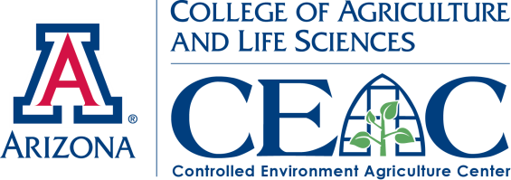 |  | News Splash  March 2013 |  | 
Valuable Workshop Activities

The Workshops are an excellent means to give hands-on, up-close, live demonstrations out of the classroom within active projects with real plants, hardware and operational greenhouse systems. Video of past workshops: http://youtube/shortcourseworkshops

Dr. Pat Rorabaugh will be leading a workshop titled “Tomato Crop Maintenance Using High Wire Systems” where attendees will be taught the basics of how to grow and manage the production of tomatoes grown hydroponically in a greenhouse.
Myles Lewis will be leading the workshop titled “Growing Lettuce and Herbs in a Floating System.” This workshop will teach certain fundamentals of hydroponic lettuce and herb production.
Both Dr. Rorabaugh and Mr. Lewis have been teaching their respective subjects for years at our January Intensive (mentioned below), which focus specifically on tomato and lettuce production. Both instructors are also offering a Q&A session later in the day, which gives allows participants to receive specific feedback to their questions and problems.

We invite those attending electronically by the Web to supplement their Distance Education by attending Intensive Greenhouse Courses for Tomatoes and Lettuce offered each January where each day includes hands-on crop production activities in the greenhouse. See the Intensive website: https://ag.arizona.edu/ceac/2013-hydroponic-greenhouse-crop-production-intensive

CEAC preparing for 12th Annual Greenhouse Short Course

Early registration & reduced hotel room rate ends March 7th
Short Course info: http://ag.arizona.edu/ceac/2013-April-Short-Course
Reserve room now at http://www.westwardlook.com/

April 7th, 2013 will mark the start of The Controlled Environment Agriculture Center’s 12th annual Greenhouse Crop Production and Engineering Design Short Course and the third year it will be held at the beautiful Westward Look Resort. This year’s edition of the short course features presentations and advice from 16 of the best controlled environment agriculture experts from around the country as well as a choice of 9 different hands-on workshops. The course has the goal to connect the theory and information given by presenters with practical hands-on experience for each participant, to ensure attendees understand and retain all of the important information given throughout the week.

The CEAC has prepared these 9 distinct workshops for Thursday April, 11th to accommodate many different knowledge levels and interests. Topics range from “My First Greenhouse” to “Alternative Energy Integrated Greenhouse System.” Short Course attendees will be driven from the Westward Look to the CEAC Campus at the University of Arizona to experience and learn from the variety of greenhouse teaching & demonstration facilities. All workshops are being led by experts that specialize in the given topic and they will be available throughout the day to answer questions and discuss your specific design and operation situations.

The CEAC is dedicated to educating people on the subject of controlled environment agriculture, its applications toward improving food production and reducing environmental impact while increases its benefits to the world.

Announcements: To learn more about the 2013 Greenhouse Crop Production and Engineering Design Short Course, please visit: http://ag.arizona.edu/ceac/2013-April-Short-Course
Visit the CEAC Facebook page and tune into what is going on at the CEAC and stay in touch with us!:
http://www.facebook.com/pages/University-of-Arizona-Controlled-Environment-Agriculture-Center/152950294760506
 | The University of Arizona  College of Agriculture and Life Sciences  Department of Agricultural & Biosystems Engineering • School of Plant Sciences  1951 E Roger Rd • Tucson AZ 85719 • 520-626-9566 • http://ag.arizona.edu/ceac
Copyright © 2012 Arizona Board of Regents

