ENVS 376 Principles of Ecological Climatology
Spring 2023
INSTRUCTOR: Julia K. Green
LOCATION & TIME: BIOW237, Tu/Th 2:00pm-3:15pm


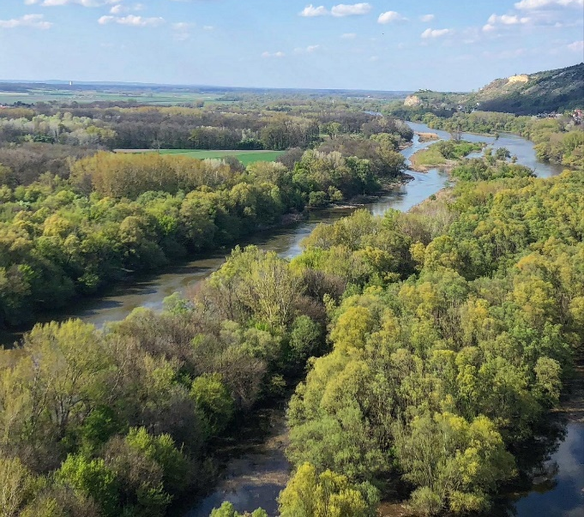
CREDITS: 3
SCOPE:
Ecological climatology is the study of terrestrial ecosystem functioning and its interactions with our climate system. As anthropogenic climate change disrupts ecosystem functioning, understanding ecological processes, how they are changing, and how they influence climate and weather patterns is essential for environmental scientists to tackle modern environmental challenges. This course will present an overview of basic principles of the earth system including topics related to global physical climatology, hydrometeorology and biometeorology.

OBJECTIVES:
- Introduce core concepts that govern the functioning of terrestrial ecosystems and their interactions with climate (e.g., the hydrologic cycle, atmospheric general circulation, surface energy fluxes and soil moisture).
- Apply critical thinking skills through review and discussion of peer-reviewed literature and scientific writing.
- Develop quantitative data analysis skills (including statistical methods) related to the physics and biology that guide climatic and ecological processes.
- Demonstrate effective oral communication skills relevant for scientific discussion with peers.

FOR FURTHER INFORMATION, PLEASE CONTACT:

Julia Green (juliakgreen@arizona.edu)

