Personal Identity Wheel
Instructions: List adjectives to describe yourself, skills you have, favorite books, hobbies, etc. Choose the top three adjectives that best describe your personal identity.
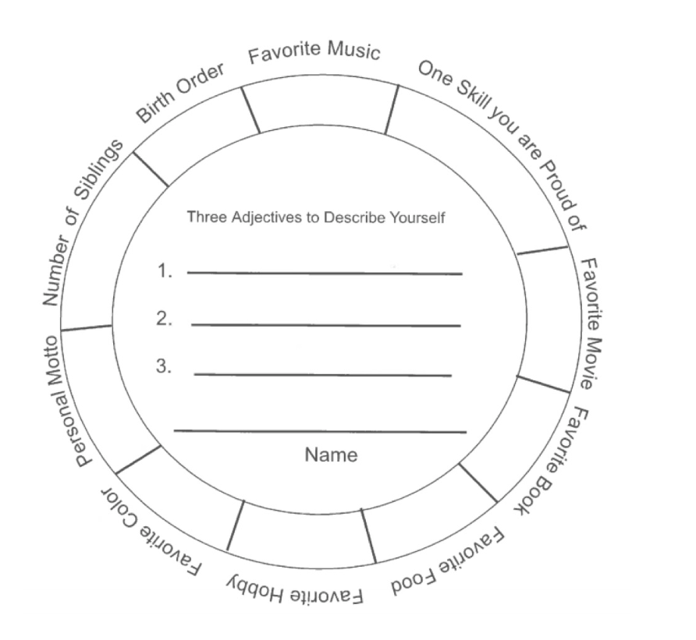

Social Identity Wheel
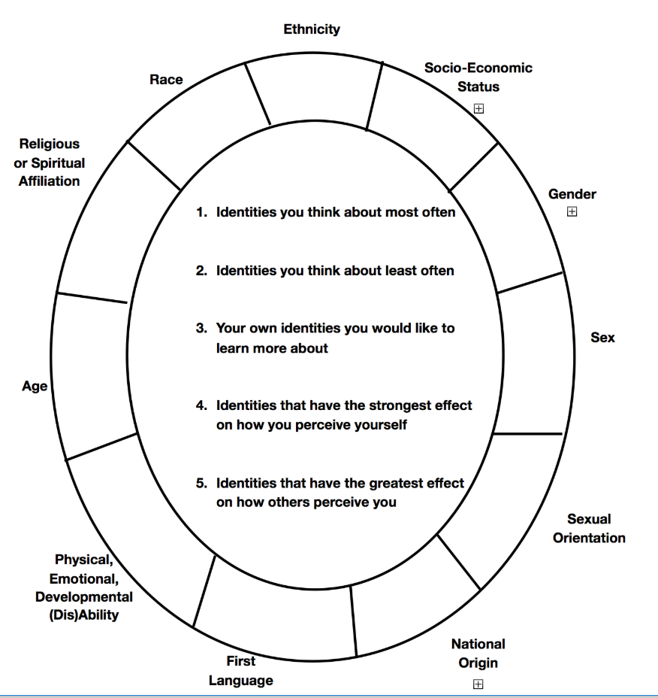
Instructions: Fill in various social identities (such as race, gender, sex, ability disability, sexual orientation, etc.). Highlight the top three prominent identities that you believe are on display at the University of Arizona. Which identities matter the most to your self-perception? Which identities matter the most to others’ perception of you?

