How to Access Your Room Key

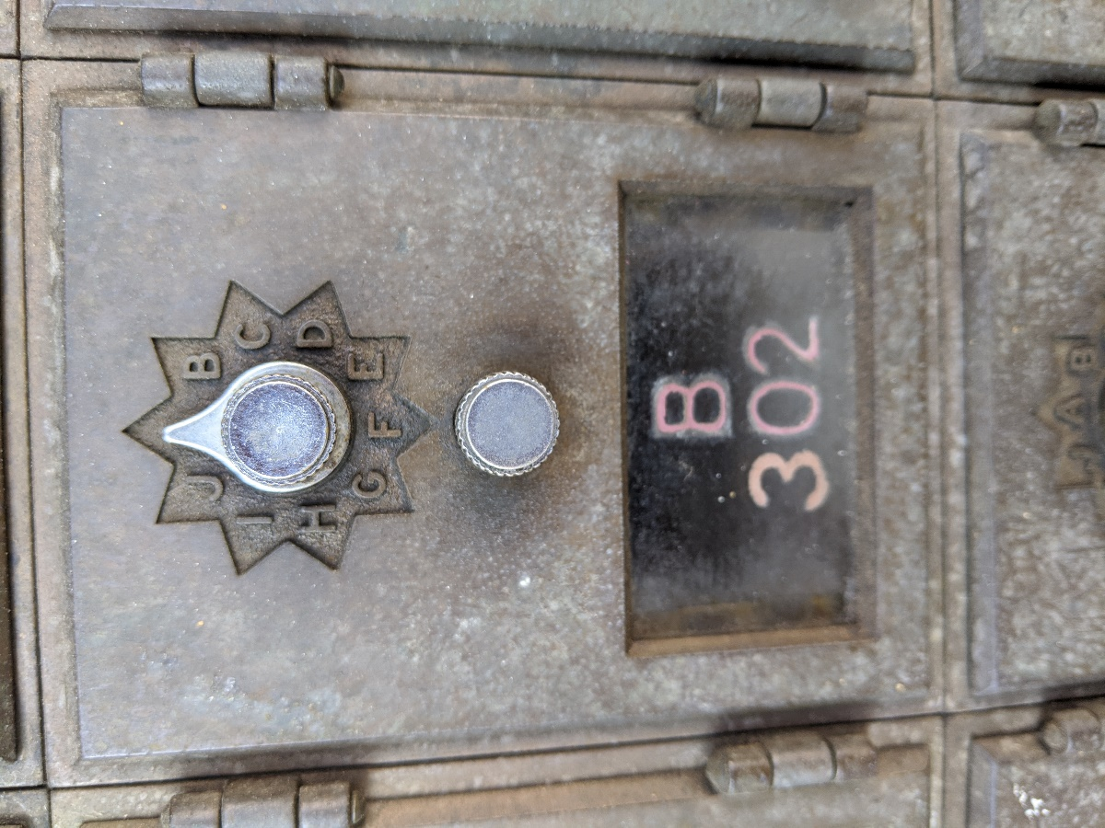

Code: A – B – C

- Turn the dial clockwise 3 times, land on A

- Turn the dial counterclockwise 2 times, land on B

- Turn the dial clockwise and immediately land on C

- Turn the bottom knob counterclockwise and pull to open box

- If there is a Double Letter (BC, HI, GF) land between the two letters

