This office is currently closed.

All student success services have been moved online.

If you need in-person assistance, please visit our temporary office, THE STUDENT SUCCESS INFORMATION CENTER, located on the first floor of the SALT Center, Patricia A. Bartlett Building, 1010 N. Highland Avenue. Please see map below.

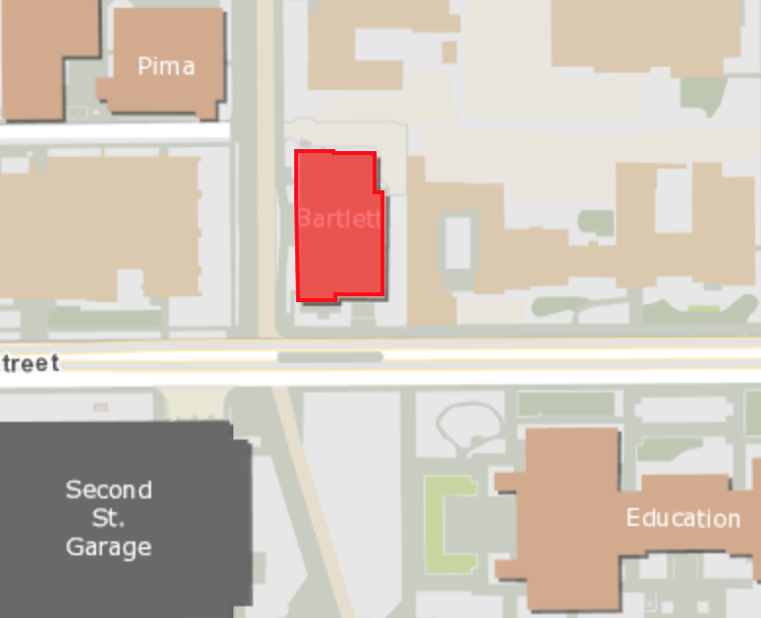

This office is open Monday-Friday from 8 a.m. to 8 p.m. until further notice.

You can reach the STUDENT SUCCESS INFORMATION CENTER at 520-621-1242.

At the Center you can receive care, support, referrals, and information about services. We are also available to help you problem solve any issues you may be facing this semester.

