Hello «First_Name»!
Priority registration for the Summer and Fall 2020 semesters is coming up in the next month. I noticed that you currently have a hold on your UAccess Student Center that will prohibit you from enrolling in classes:
«RISK_VALUE»
Therefore, in order for you to remove your hold, you will need to act to resolve it. You should view more information in your UAccess Student Center by clicking on the “details” link on the upper-right side of your UAccess Student Center homepage. Those details will let you know how to resolve your hold or whom to contact to begin the process. It will look similar to this:
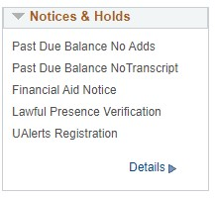

I strongly encourage you to work on resolving and getting this hold removed as soon as possible so that it does not affect your ability to register for Summer or Fall 2020 courses during your Priority Registration, which is when you will have the best selection of courses for you to enroll in.
Please let me know if you have any additional questions. I am here to support you!
«Advisor»

