Trellis Sprint update meeting 10/2/19
Mobile student experience from advisor and student side are under construction. Update to student view has been completed. All images are screen shots of the Zoom shared screens.
The below is from student mobile view.
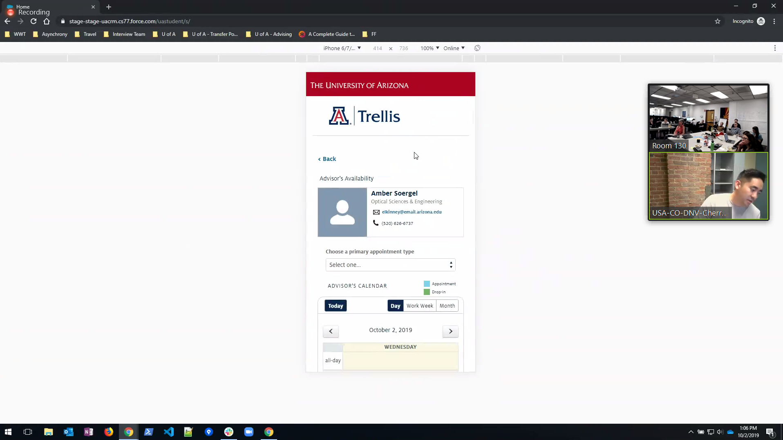
Default is day view to student, they can now scroll back and forward to see other dates.
There is now a month view too.
Filtering from drop down menu is functional.
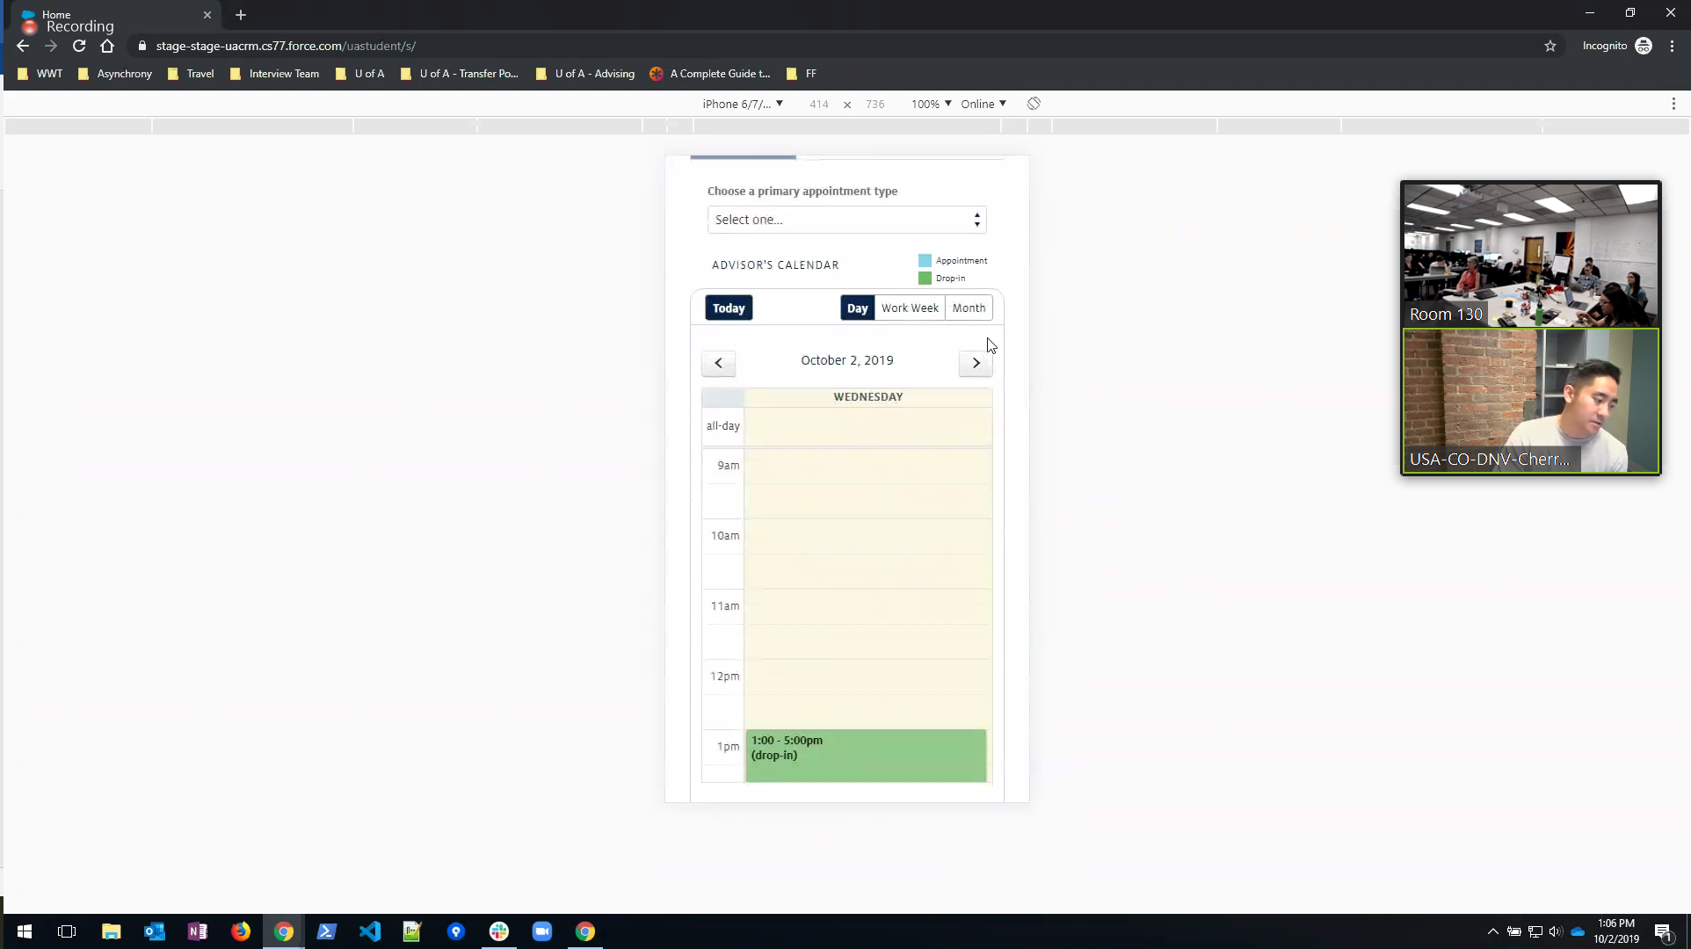

Colors are still different from student side and advisor side, but will apply to advisor side in the future so that both are the same colors. Currently they are using visually impaired color coding for the student side.
Student calendar is scrollable and more usable and has their schedule appointments listed for them to see when they are attempting to schedule another appointment.

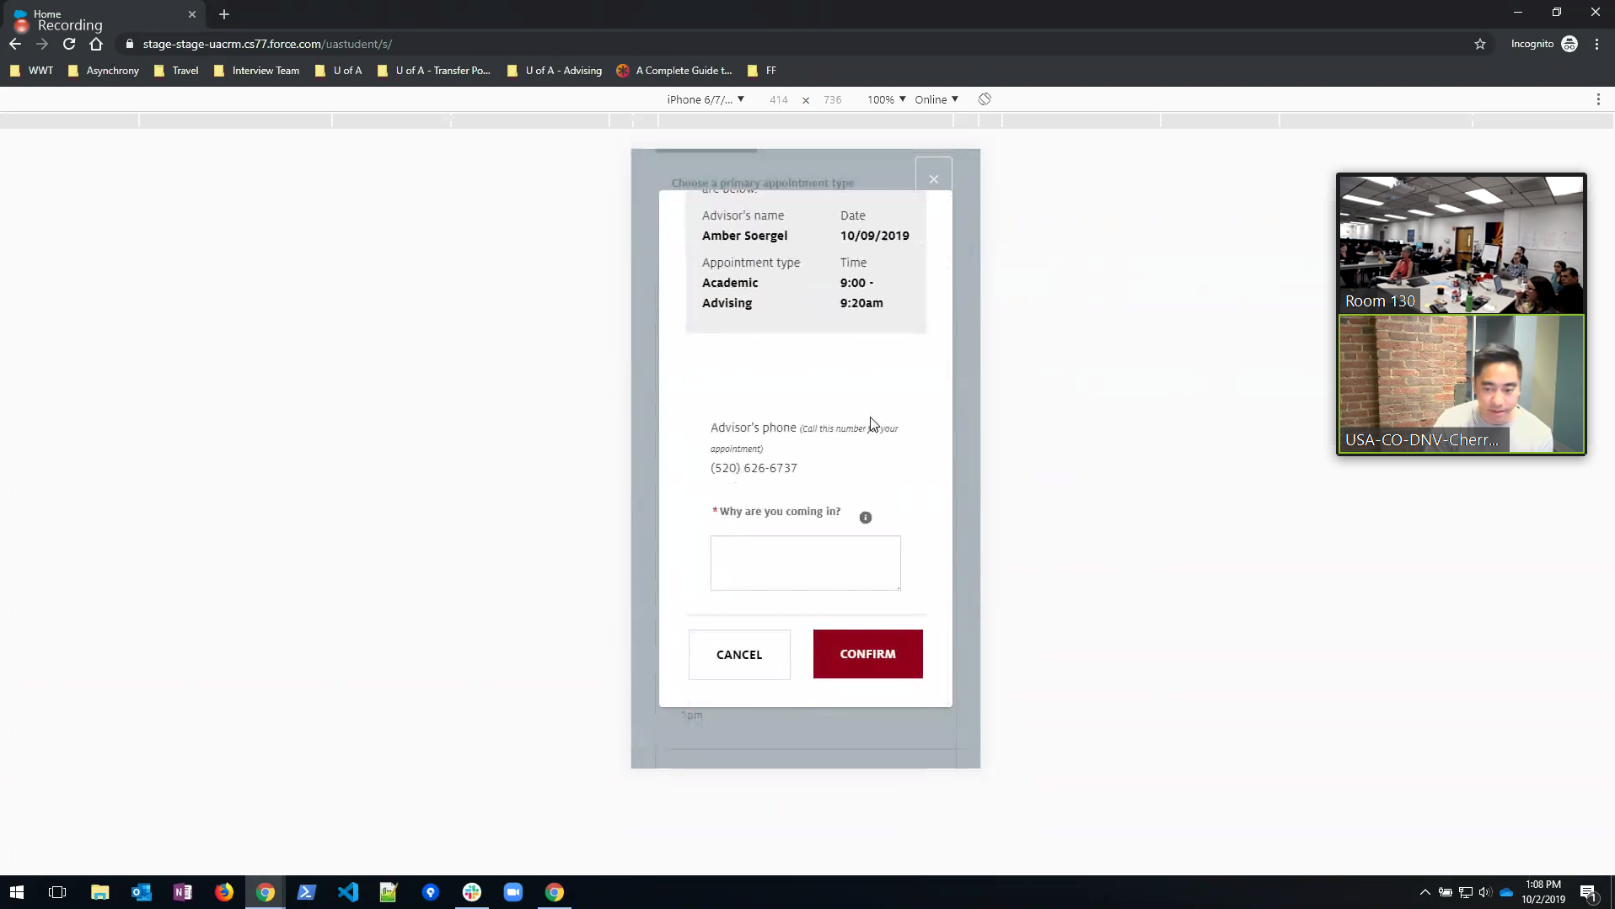

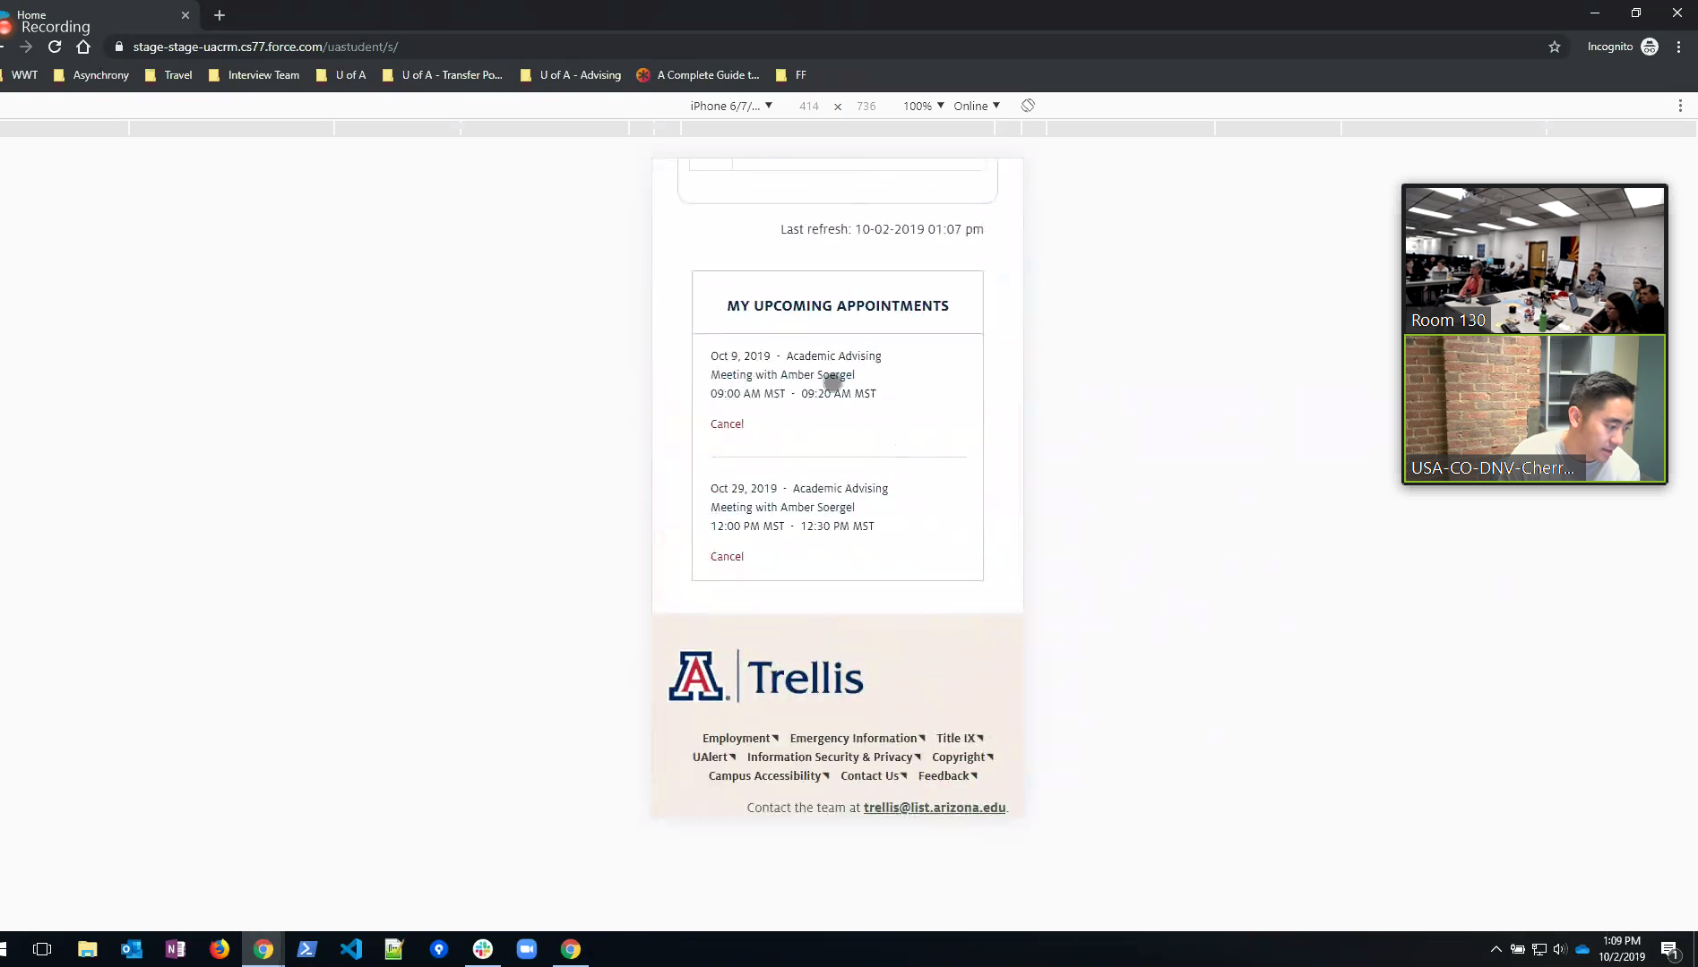

Research completed on seeking info regarding direct links to Trellis calendars for students. Their next step is to move forward with breaking up student communities to have direct links. More to come.

Completing work on other people managing advisor calendars, (someone like Maria Bueno for CAS).

Appt check-in reminder to student is being worked on right now.

Checking in students from a front desk, the advisor receives an alert on Trellis, a red dot near the ‘bell’ icon in Trellis.
--I asked the group if there is a way for the tab to show an alert or a sound so the advisor doesn’t have to keep checking the status for a change. The team will look into that.
The image below is the drop down from the ‘bell’ icon so that advisors can view who has been checked in, this was a production testing view with the same student checked in for example purposes in this meeting.
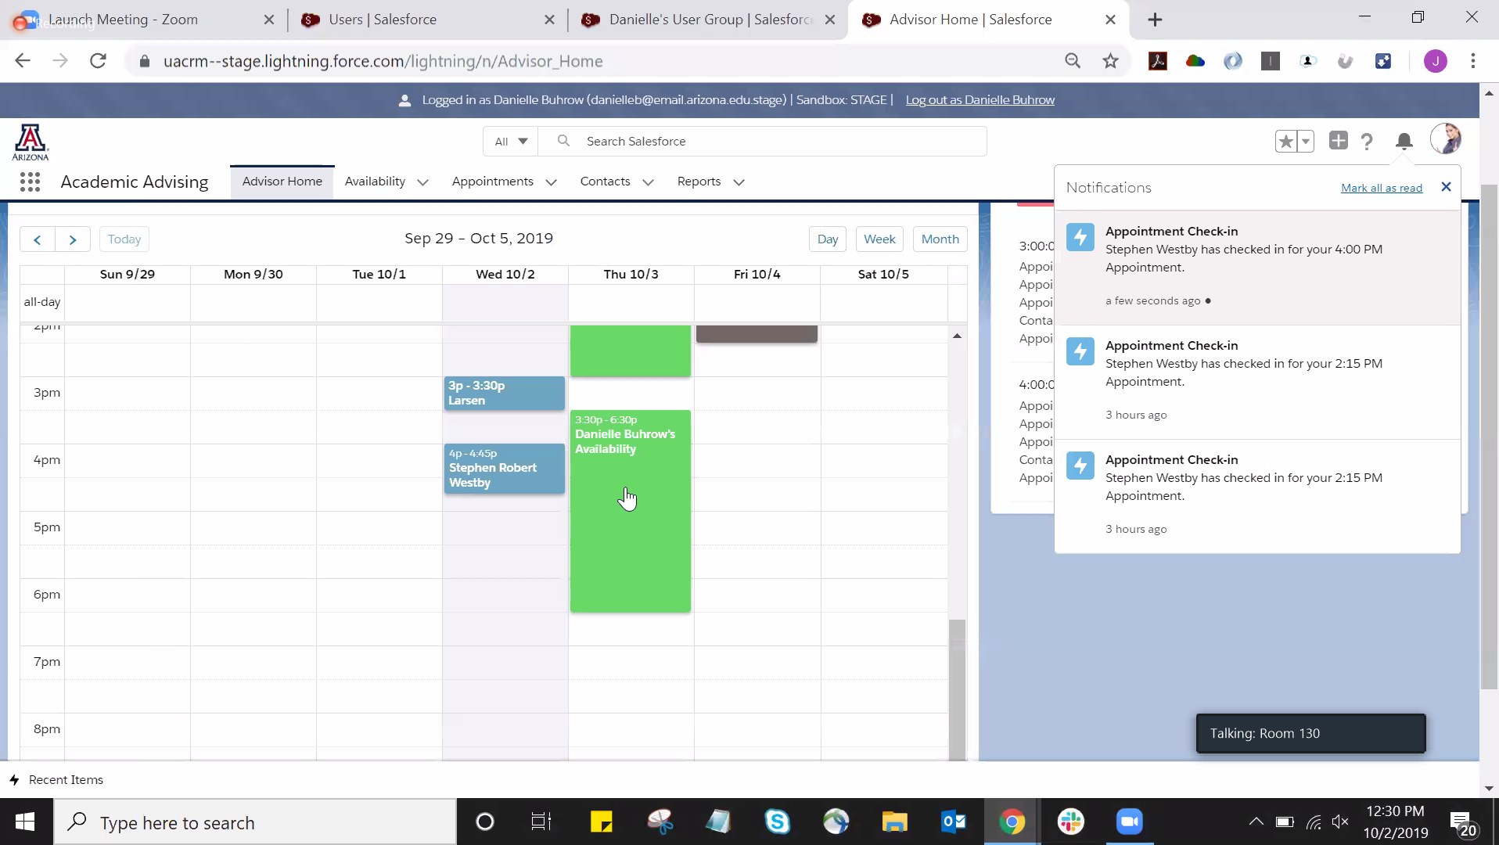

The team is working on allowing those advisors and staff who are also UA students to allow log in ability in both worlds. Right now they cannot be in both.
End of meeting.

