BE 120 Basic Computer Skills
for Office Applications
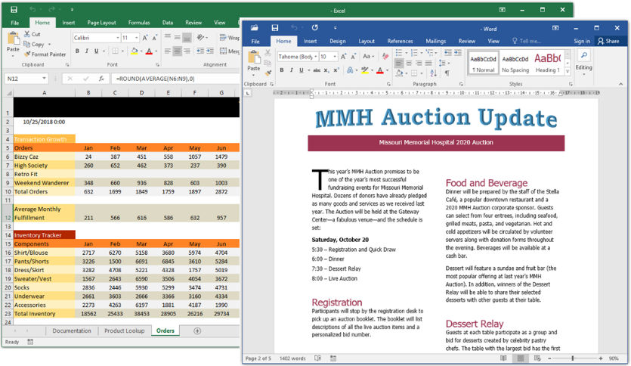
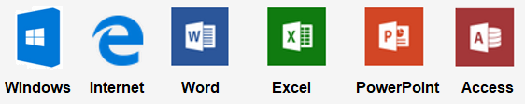
Summer 2019
Get 3 units while learning and developing your cyber skills on:
- Important Computer Concepts (Hardware and Software)
  - Computing basics
  - Operating systems
  - Cloud Computing
- Windows Operating System
- File Management
- The Basics of Internet, browsers and e-mail.
- Productivity Apps for School and Work
- Microsoft Office 2016/365 Applications covering Word, Excel, PowerPoint and Access.
- Integration of PowerPoint with Excel and Word applications.

