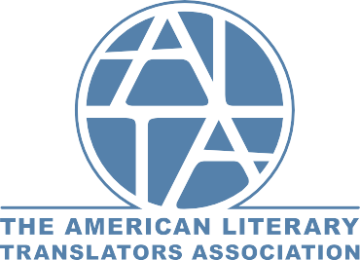

Dear friends at the University of Arizona,
We at the American Literary Translators Association (ALTA) are very excited to be settling into our new home on the UA campus—as of January 1, we are associate partners of UA and the College of Humanities! We've been delighted to meet our translator colleagues here in Tucson, and we are looking forward, with you, to furthering our mission to support the work of literary translators, advance the art of literary translation, and serve translators and the students, teachers, publishers, and readers of literature in translation.
ALTA fulfills this mission in a number of ways: offering awards that recognize excellence in literary translation; providing the support that emerging translators need as they get started in their careers; and hosting our annual conference, the largest gathering in North America dedicated exclusively to literary translation. We look forward to the ways in which our affiliation with UA and the College of Humanities will strengthen what we already do, and contribute to the field of literary translation—together. And get excited: our conference will be held here in Tucson in 2020 and 2022!
As part of our partnership, ALTA is delighted to extend a special offer to the UA community: a 50% discounted ALTA membership to all faculty and employees, and a free membership to University students pursuing studies in translation. ALTA members are freelance translators, university professors, educators, publishers, and more. They have won the Man Booker International Prize, have founded translation presses and blogs, edit literary journals, and work to bring diverse world literature to English-language readers.
ALTA membership includes the ability to propose sessions at our annual conference; priority selection for our various programming; access to members-only content, including a monthly listing of translation grant, prize, and residency opportunities, community forums, and our listserv; a print and digital subscription to Translation Review; a digital subscription to World Literature Today, and much more. To find out about membership levels and related benefits, and to join, please see our website.
To join as a Translator Member at a 50% discount, use code: UofATranslator
To join as a Friend (non-translator) Member at a 50% discount, use code: UofAFriend
To join as a Student Member at full discount, use code: UofAStudentComp
At the heart of our organization is a belief in community: that as members of ALTA, we come together to keep learning from each other, celebrating each other’s work, advocating for translation and translators, and helping to advance the art of literary translation. We at ALTA are looking forward to welcoming you into our community, as you have welcomed us into yours. To find out more, visit our website or come by our new offices in Esquire Building #205 and say hello!
Yours,
Elisabeth Jaquette, Executive Director
Kelsi Vanada, Program Manager
Rachael Daum, Communications & Awards Manager
THE AMERICAN LITERARY TRANSLATORS ASSOCIATION
The University of Arizona
Esquire Building #205 | 1230 N. Park Avenue | Tucson | AZ 85721 www.literarytranslators.org

