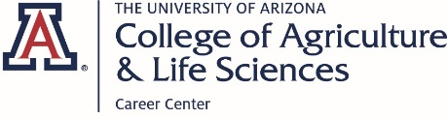

2nd Annual CALS Career Fair Employers

Table # | Employer Name | Industry | Internships?
1 | Enterprise Holdings | Transportation/Travel | Yes
2 | Elanco | Animal Healthcare | Yes
3 | Project CENTRL | Leadership | No
4 | 5 Rivers Cattle Feeding | Livestock Production | Yes
5 | AXA Advisors | Financial Services | Yes
6 | Shamrock Food Company | Food Service Distribution | Yes
7 | Rillito Park Foundation | Non-profit/Horse Racing | Yes
8 | US Fish and Wildlife Service | Government Agency | No
9 | USDA APHIS PPQ | Government Agency | Yes
10 | RDO Equipment/ RDO Water | Equipment Sales and Service | Yes
11 | Vanguard | Financial Services | Yes
12 | Bayer Crop Science | Plant Products | Yes
13 | Accelerate Diagnostics | Medical Diagnostics | No
14 | Boehringer Ingelheim | Animal Health
15 | Barkley Ag Enterprises | Vegetable Production
16 | Stantec Inc. | Water/Design Consulting | Yes
17 | Riverview LLP/ Coronado Dairy | Dairy Production | Yes
18 | Merck Animal Health | Animal Health | Yes

