ENVS 300 Soil Ecology
Fall 2018
INSTRUCTOR: Dr. Joey Blankinship
LOCATION & TIME: MWF 9:00-9:50am
Biological Sciences EAST room 313

CREDITS: 3 units

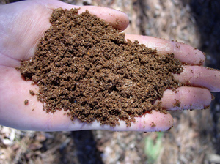

SCOPE:
Properly functioning terrestrial systems, whether natural or agricultural, depend on interactions between diverse soil organisms and their micro-environments. This course will serve as an in-depth introduction to the rapidly evolving field of soil ecology, including soil food webs, microhabitats, plant interactions, linkages to critical ecosystem services, vulnerabilities to climate and land use changes, and real-world opportunities for applying soil ecological principles and mechanistic understanding to achieve sustainable environmental goals.

OBJECTIVES:
This course builds upon knowledge gained in ENVS 200. From your basic knowledge on soils and ecosystems, we will further investigate the broader impact that soil has on the Critical Zone and the impact of managed soil systems on the peripheral environment and greater biosphere. During the course, we will be investigating:
1) Further exploration of soil ecology predicated on knowledge gained in ENVS 200.
2) The subsequent impact that soil has on microbes, plants, and animals.
3) From a greater understanding of Critical Zone health, we will then learn to evaluate soil for ecological impact and management.

FOR FURTHER INFORMATION, PLEASE CONTACT:

Dr. Joey Blankinship, jblankinship@email.arizona.edu
(520) 621-9229

