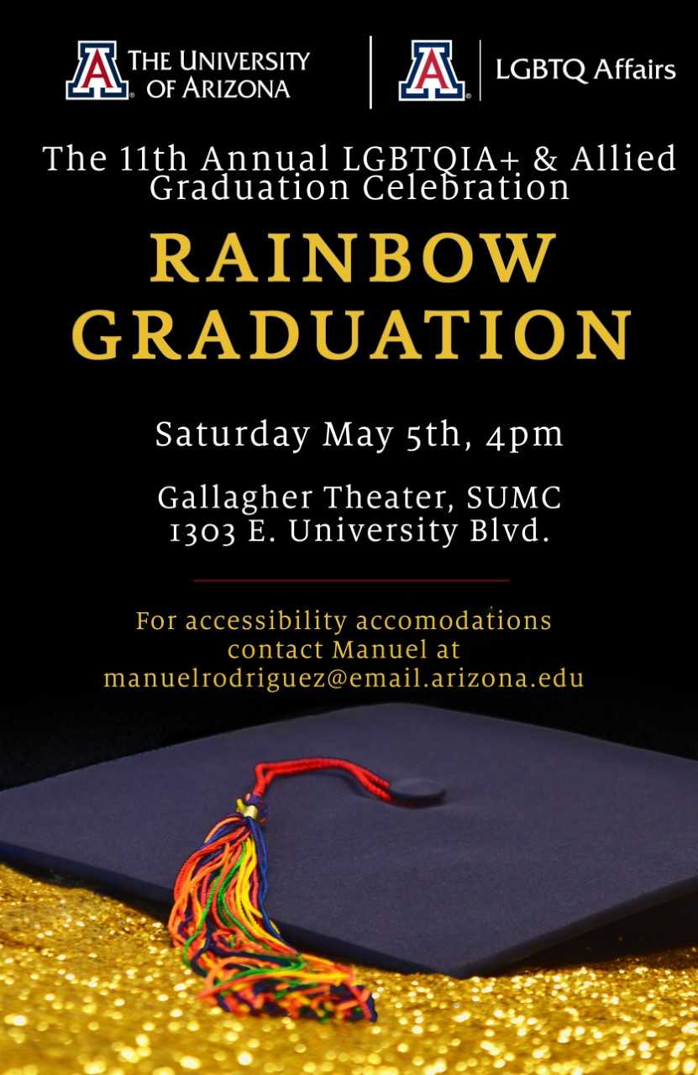

Call for Graduates

Are you graduating this May (or December 2018)? Do you want to participate in a graduation ceremony that recognizes and celebrates the achievements of underrepresented sexual and/or gender identity(ies) at the UA? Rainbow Graduation is open to all graduating undergraduates, graduates, or professional school students (including allies!) to show their fabulous wildcat pride!

Be recognized for your academic efforts and achievements at the 11th annual Rainbow Graduation on Saturday, May 5th at 4pm in Gallagher Theater in the Student Union. Graduates will receive a rainbow cord, a certificate, and will be the guests of honor at a catered reception following the ceremony.

If you would like to participate, please fill out the google form here that will contain all of the below information. The only information not on the google form is the photo, which must be emailed to uarainbowgraduation@gmail.com by April 23rd @ noon:

The information we will need from graduates is:
1. Your name as you'd like it to appear on your certificate
2. Major(s)
3. Graduating degree
4. Career goal(s)
5. Your favorite quotation
6. Any leadership positions you have held in an organization that does social justice and/or LGBTQ+ community work
7. Accessibility needs for accommodations
8. Electronic picture of yourself
This information will be included as part of a PowerPoint presentation that will be shown as you are recognized during the ceremony.
-and-
9. The name, email address, and phone number of your presenter:
As a graduating student, we ask that you please select someone who will present you with your rainbow cord and certificate. The person you select will have 30 seconds to say a few words about you. This person could be a friend, partner, family member, professor, mentor, neighbor, or whomever you choose.
*If you are having trouble finding a presenter or have any concerns about the presenter in general, please let us know. We can work with you and can make accommodations to ensure you have the best experience possible.
Please fill out the google form and send us your photo uarainbowgraduation@gmail.com by April 23, 2018 @ noon (or sooner if you can)! Please make sure to include all of the requested information!

Here are all the details for the event:

Rainbow Graduation 2018:
The 11th Annual LGBTQA & Allied Graduation Celebration
Saturday, May 5th, 2018
4pm to 6pm
Gallagher Theater, Student Union, 1303 E. University
This festive and intimate end-of-the-year celebration will provide personal recognitions for the achievements of underrepresented sexual and/or gender identity(ies) at the UA. Rainbow Graduation is open to all graduating undergraduates, graduates, or professional school students (including allies!) to show their fabulous wildcat pride! Each graduate will receive a rainbowcord and certificate of honor, and a catered reception will follow the ceremony. You must register by April 23rd to participate.

We look forward to honoring you in May!
-The Rainbow Graduation Planning Committee

Please Nominate a Fabulous Faculty/Staff Member!
RAINBOW GRADUATION 2018

We need YOUR HELP recognizing a fabulous Faculty/Staff member to be honored during Rainbow Graduation this year!

Do you know someone who has been fabulous to you, makes this campus fabulous, or both? Do you want to show them your appreciation for being so fabulous?

Nominate them for the Fabulous Faculty/Staff award presented at Rainbow Graduation!

Below is the link to nominate your fabulous Faculty/Staff member (you can nominate more than one)!

Complete the Nomination form here: https://goo.gl/forms/FN3yGX9CT21S5dBh2

Please fill this out before April 6th, 11:59pm. To learn more about this award or see past recipients, visit our website.

You all make this campus a fabulous place—THANK YOU!

