







PIZZA PARTY!!

Thursday, February 8th − 5:15 - 6:30 pm ENR2 building, room S120A
(next to the Slot Canyon Café)
Join us for free pizza and conversation about the program, climate justice, and new scholarship options!

Be Anywhere Learn Everywhere

Costa Rica: Climate Justice

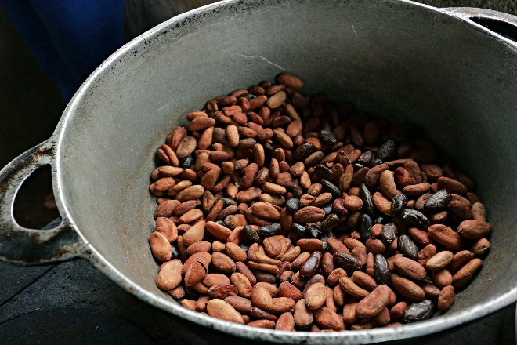
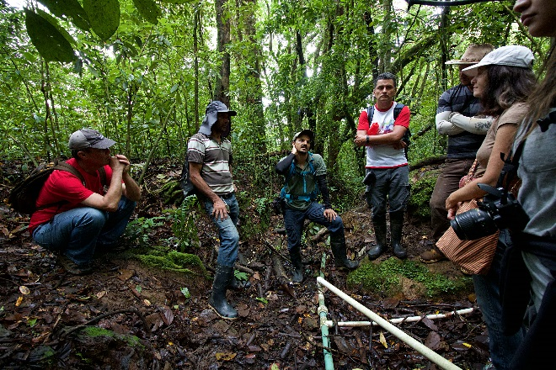
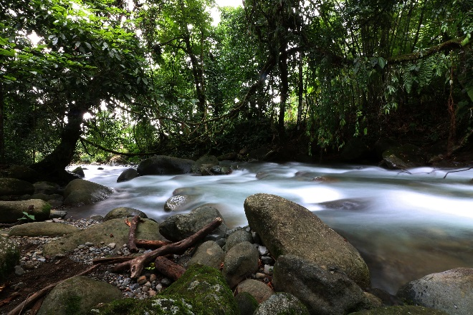
Program Overview | At this historic moment when fierce debates over our planet’s natural resources are taking place everywhere, this program will focus on how compassionate personal and community resiliency are created in a time of climate change. The program has three parts:
- An overview of the personal and community character traits and skills necessary to bring about resiliency and change
- A review of the rapidly changing documentation—scientific, academic, artistic, testimonial--about this movement
- Personal stories about the lived experience of building these movements from powerful leaders, many of them young.
Students will spend their days in a combination of community-based work (planting trees and gardens, installing water systems, gathering data about rivers), classroom discussions and time by rivers to sit, meditate, and reflect.

What’s included? | Tuition, Housing, Meals and International Insurance
Units | 6 credits in RNR
Faculty | Oscar Beita, obeita@email.arizona.edu
Madeline Kiser, mkiser@email.arizona.edu
Requirements | 2.5 GPA
Study Abroad Coordinator | Katie Van Wyk, kvanwyk@email.arizona.edu

