What are Early Progress Grades?
Early Progress Grades are an opportunity for our first year students to get early course feedback through UAccess in select first year courses. This grade provides them an opportunity to make adjustments and seek resources as needed. In anticipation of student response to their early progress grades, it is important that as a campus community we are prepared to support, engage, and challenge our students to be active participants in their academic success. Our hope is that student interactions with instructors and advisors, along with larger institutional messaging, provides an early intervention opportunity. Messaging would include “What now?” scenarios, encouraging them to evaluate their progress, having quality discussions, and connecting with academic support programs, e.g. Think Tank.

Who is getting them?
An estimated 13,747 early progress grades will be posted for 9,675 unique students this fall. The majority being freshmen, but will also include upperclassmen. This year we have added ACCT 200, ACCT 210, MATH 107, and MCB 181R to the participating courses.

For which courses and when?

Course | Sections | Available | Early Progress Grade Consists Of:
ACCT 200 | 1-5 | 9/29/2017 | All graded work – no drops. This includes Exam 1, Financial Statement HW 1, 4 in class clickers and 6 Wiley homeworks.
ACCT 210 | 1-2 | 9/25/2017 | All graded work – no drops. This includes Exam 1, 3 clicker assignments, 3 WileyPLUS homework assignments, and any participation points awarded as of Exam 1 on 9/14.
BNAD 100X | All | 10/6/2017 | Assignments and attendance weeks 1-6
CALS 100X | 1-3 | 10/6/2017 | Assignments and attendance weeks 1-6
CALS 195C | 1-4 | 10/6/2017 | Assignments and attendance weeks 1-6
ENGL 101 | All | 10/13/2017 | Early Progress Grade will all graded items, which will include all graded items in Project1 and graded homework (approximately 40% of the course grade).
ENGL 101A | All | 10/13/2017 | Early Progress Grade will all graded items, which will include all graded items in Project1 and graded homework (approximately 40% of the course grade).
ENGL 102 | All | 10/13/2017 | Early Progress Grade will all graded items, which will include all graded items in Project1 and graded homework (approximately 40% of the course grade).
ENGL 106 | All | 10/13/2017 | Early Progress Grade will all graded items, which will include all graded items in Project1 and graded homework (approximately 40% of the course grade).
ENGL 107 | All | 10/13/2017 | Early Progress Grade will all graded items, which will include all graded items in Project1 and graded homework (approximately 40% of the course grade).
ENGL 108 | All | 10/13/2017 | Early Progress Grade will all graded items, which will include all graded items in Project1 and graded homework (approximately 40% of the course grade).
ENGL 109 | All | 10/13/2017 | Early Progress Grade will all graded items, which will include all graded items in Project1 and graded homework (approximately 40% of the course grade).
LASC 100X | 1-29 | 10/6/2017 | All assignments weeks 1-7
LASC 197M | 1-29 | 10/6/2017 | Required and Optional Assignments through GradeCraft weeks 1-7
MATH 107 | 1 | 10/4/2017 | Exam 1 and first two "Excel Homework" assignments
MATH 112 | 1-73 | 10/2/2017 | Exam 1
MCB 181R | 1,3,5,9,11 | 10/6/2017 | All graded items at that point
MIS 111 | 1-9 | 10/2/2017 | Attendance, Homework, Exam 1, and Project 1 (1/3 of the grade)
SBS 100X | 1-11 | 10/11/2017 | Assignments and attendance weeks 1-7
SBS 197A | 1 | 10/11/2017 | Assignments and attendance weeks 1-7

Where can I access the grade reports (with required access)?
UAnalytics-> Dashboards -> Student -> Student Detail -> Early Progress Grades. You will be able to filter by college

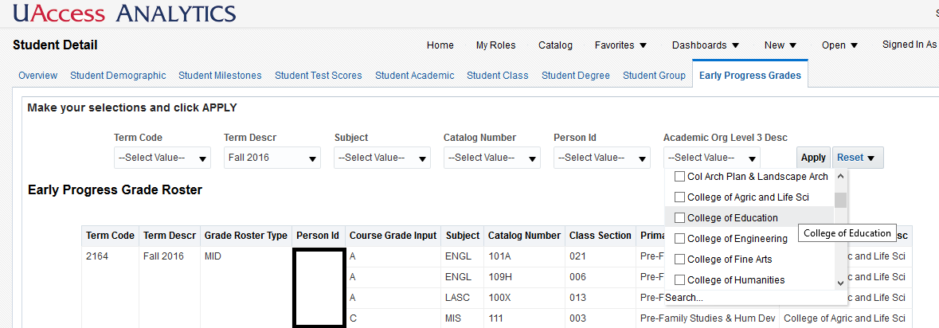

How students will see these grades in UAccess:

