Degree Map Validation

Important note
Degree Map is STILL IN DEVELOPMENT. You are welcome to play around with the tool, but know that this is only the 2nd of 4 releases before we go live, and there are many known issues being worked on. New functionality and many fixes are in the pipeline, based on advisor input. Anything you do in the tool from now until September will be deleted, so you cannot possibly break anything.
The validation work we are asking you to do is specifically how the ADVIP flows into Degree Map for your majors and minors (the left hand column of data), and NOT the performance of any of the degree mapping, degree exploration, or career exploration functionality, all of which is still very much in development.

Preparation:
- Make sure you have a gmail account. You will need this to access Google Sheets and Google Forms for input.
- Choose 1 student for each of the 4 most recent catalog years (4 total). I would recommend choosing students who have few major/minor/premajor requirements fulfilled.
- Print out or pull up ADVIPs for each of those students.
- Open Degree Map by going to: https://arizonadm.civitaslearning.com
  - I have given all validating advisors login permission. If for some reason you can’t get in, please send me your employeeID and I will ensure you’re added properly (maronson@arizona.edu)
  - You should see the following UA Webauth screen:
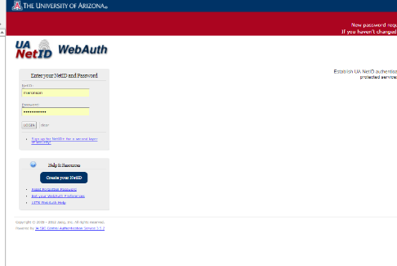

  - You should land on this page:
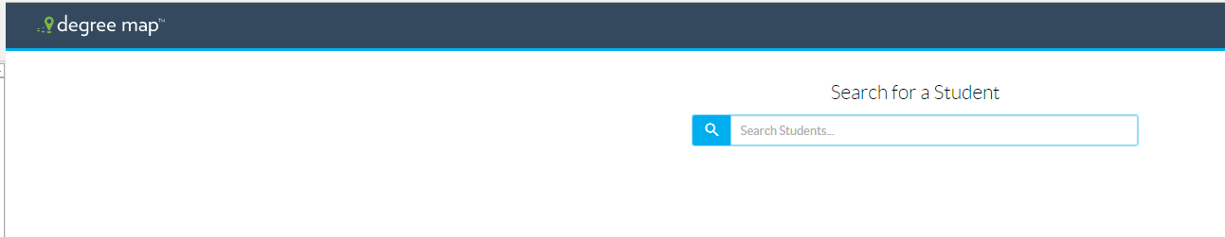

  - Type in a student using Student ID or name.
- Go to https://docs.google.com/spreadsheets/d/1Swh-Vfnkz_EymLNL5xJq3ulp7S-Ii7QDFAKlj4zItPg/edit?usp=sharing to review the plans you are responsible for validating. You can filter on College, Department to review plans. Just know that there are multiple columns for validators, so you may need to confirm which plans are yours by searching all validator columns.

Validation
- There are two things that need to be validated for your majors and minors:
  - requirements/requirement groups showing up properly for your plan/subplan, and
  - the courses populating for your plan/subplan are correct.
You will review the General Education requirements to ensure none of your major/minor requirements show up in the “Undergraduate” section; but you will NOT need to review courses within General Education requirements.
- Go into Degree Map, “Degree Progress” page, paying attention ONLY to the left hand column
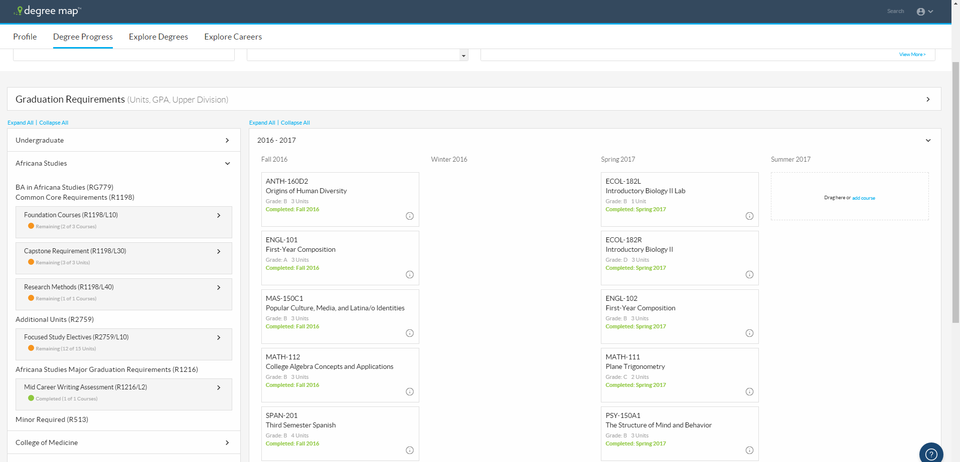
- Using the arrow on the right of the major/minor, open out the list of requirements and compare them to the ADVIP for completeness. All requirement groups and requirements from your ADVIP should be in Degree Map. Note that you should check the “Undergraduate” area also, to ensure there are not any requirements there that belong in your major/minor instead.
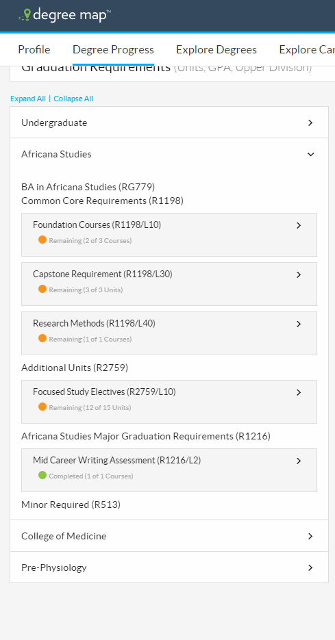
- Next, use the arrow within each requirement and open the “plan course” options to check the courses offered. Do this for each requirement group/requirement. Ensure that this list aligns with the ADVIP and note any differences.
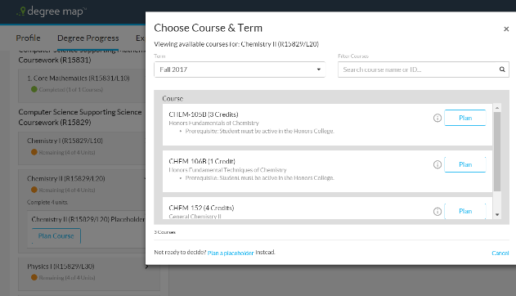
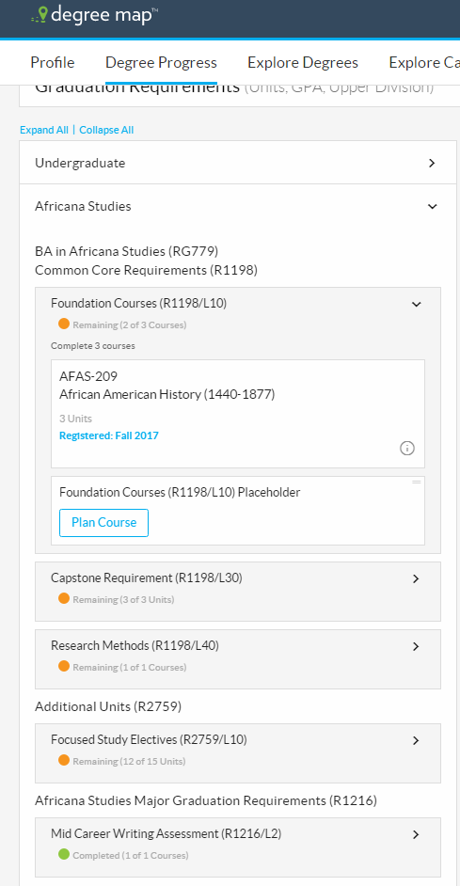
- For each plan that you are reviewing, your input will go into the Google Sheet https://docs.google.com/spreadsheets/d/1Swh-Vfnkz_EymLNL5xJq3ulp7S-Ii7QDFAKlj4zItPg/edit?usp=sharing . If there are no issues, you only need to answer “Yes” and add your initials to each of the two questions. If there are issues, answer “No”, add your initials, and then you need to follow the link to a Google Form to provide detailed input on the issues. Note that if you are reviewing online/distance plans, those are two additional columns on the right.
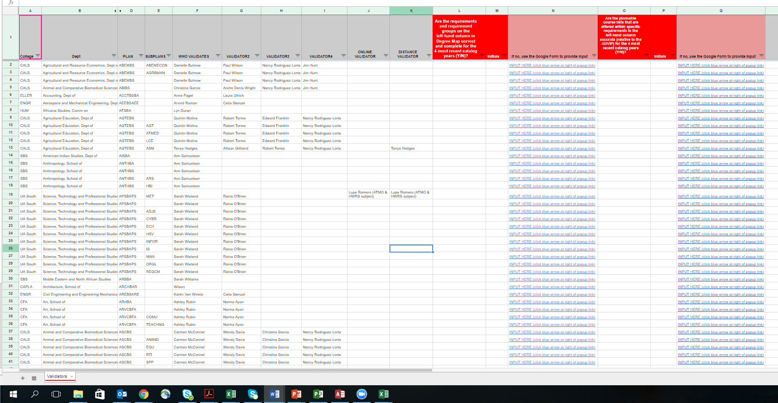

- Note that in the forms that are offered for each of the two questions, the google form allows you to upload a file with more detail (at the very bottom of the form) if you find that the form is not allowing you to provide sufficient detail.

- Make sure to SUBMIT the forms by hitting the blue “SUBMIT” button, which is at the very bottom of each Google Form.

Note that there will be a way to sort remaining, completed, registered courses in the left column in future.

