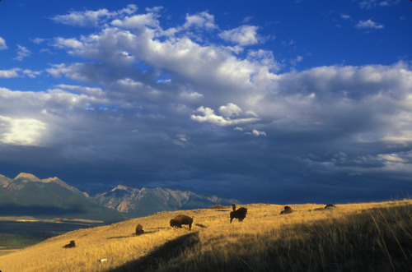
WILDLIFE, CONSERVATION and AMERICAN CULTURE
Tier 1 “Traditions and Cultures” general education course
- No prerequisites
- 3 units
- Summer Session I (June 5 – July 6)

Online course: RNR 160D1
Open to students in all majors

Questions? Write to Valerie Rountree vrountree@email.arizona.edu in the
School of Natural Resources and the Environment

