Enumerators Wanted
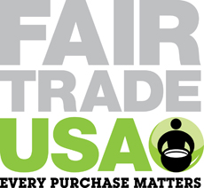

Organisation Description
Fair Trade USA is the leading third-party certifier of Fair Trade products in the United States. Fair Trade USA audits and certifies transactions between U.S. companies and their international suppliers to guarantee that the farmers and workers producing Fair Trade Certified goods are paid fair prices and wages, work in safe conditions, protect the environment and receive community development funds to empower and uplift their communities. Fair Trade USA educates consumers, brings new manufacturers and retailers into the Fair Trade system, and provides farmers with tools, training and resources to thrive as international businesspeople.

We are currently hiring for the position of Survey Enumerators.

The roles involve:
- Spending 2-3 days per week collecting data via tablets

- Participating in trainings on data collection
- Field testing questions for feedback and question improvement
- Providing feedback on logistics and communication for the regional context

Note: This is a temporary short term contract, with the possibility of future contracts for surveys run in this geographical location
Compensation: $10/hour, plus transport and housing.

Enumerator Skills Desired
Skills and Qualification

- Good spoken and written English
- Fluency in Spanish
- Cultural understanding of the local context and familiarity with the region
- Expertise in agriculture and the vocabulary associated
- Strong work ethic and attention to details
- Comfortable with technology and math
- Ability to think critically
- Excellent written and verbal communication
- Commitment to helping your community
- Ability to prioritize tasks and juggle multiple responsibilities
- Strong personal organization
- Positive attitude
- College Level Education desired
- A past experience in data collection will be an added advantage
- Unbiased with no conflict of interest with the party to be surveyed

All interested candidates should email nancyr@email.arizona.edu

