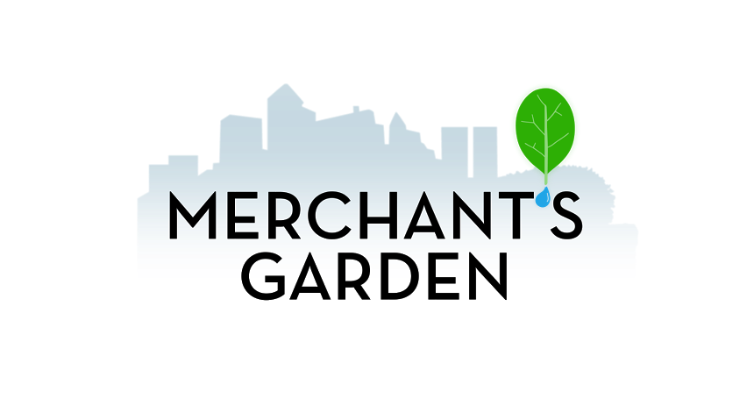
Internship Starts: May 1st
Internship Ends: Aug 1st
Number of Interns: 2
App Deadline: April 7, 2016
Stipend: Yes - $500/month
Creating revolutionary and sustainable ways to feed the world with local produce.

Urban Farm Internship
Qualifications
- Currently enrolled as an undergraduate or graduate student, or recently graduated.
- Degree focus must be in a Engineering, Public Health, or Agriculture major or related field of study and demonstrate an interest in pursuing a career in agriculture or related field.
- Previous experience in agriculture, horticulture, nutrition, engineering, and/or teaching preferred but not required
Requirements
- Must be able to lift 40 lbs. and comfortable working outdoors
- Sitting, standing, kneeling and bending on uneven work surfaces.
- Applicants must have their own transportation
- Extraordinary organizational and communication skills required

Position
The Agricultural Research Internship Program is a hands-on learning experience during which interns aquaponics & hydroponics farm. This experience is an introduction to the various themes in Controlled Environmental Agriculture biological research, supply-chain management, and logistics management. Each week consists up to 20 hours (up to 40 hours in summer) of manual labor complimented by professional development. The intern is required to conduct a research project and present the findings to the company’s team members at the end of the internship.

About Merchant’s Garden
T
he Merchant’s Garden is changing the way the world accesses healthy food. Bringing a computer controlled aquaponics greenhouse into the City will change the way the city eats. The Merchant’s Garden provides out-of-season produce to restaurants, grocery stores, and for home consumption. This is made possible by leveraging the science of aquaponics and hydroponics in a computer controlled greenhouse environment. It is a combination of business-to-business and business-to-consumer sales. It houses the entire supply chain: we build, grow, harvest, and deliver locally produced food. This is a local production for local consumption model based in Southwest Arizona.

Mission Statement
Make fresh food accessible and affordable to everyone using the science of aquaponics and hydroponics.

Vision
Create revolutionary and sustainable ways to feed the world with local produce.

Location
555 S Tucson BLVD. Tucson, AZ 85716. 1.5 miles from Campus

To apply please email your resume and cover letter to giovanna@merchantsgarden.com and cc chaz@merchantsgarden.com by April 7th @ 5PM MST.

