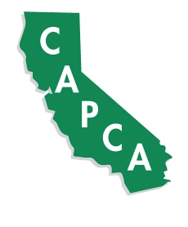
CAPCA DESERT VALLEYS CHAPTER
SCHOLARSHIP INFORMATION

Each year the Desert Valleys Chapter of the California Agriculture Pest Control Advisors Association (CAPCA) awards two scholarships to deserving students who reside in the desert areas of Southern California and/or Western Arizona. The Desert Valleys Chapter includes members from Coachella, Imperial, Bard and Blythe Valleys of California, as well as the Yuma, Gila, Dome, Wellton-Mohawk and Parker Valleys of Arizona.

One $2,000 scholarship is specifically for a graduating senior high school student and who has an interest in the field of agriculture including agronomy, entomology, soils, or related fields with the objective of a career in pest management, agronomy, plant breeding or farming.

One $2,000 scholarship is specifically for a college student who has an interest in the field of agriculture including agronomy, entomology, soils, or related fields with the objective of a career in pest management, agronomy, plant breeding or farming.

Your application must be filled out and postmarked by May 2nd, 2016. Complete the application in full, attach your transcripts and mail to:

Desert Valleys Chapter CAPCA
C/O Mike Terry
78-580 Ave 41
Bermuda Dunes, CA 92203

For general information please contact:
Mike Terry 928-941-8960. MTerry@wilburellis.com

Regional Contact Information
El Centro, Imperial, Calexico | Frank Miranda | 760-457-5758 | fmiranda@rockwoodchemical.com
Holtville | Pedro Velasquez | 760-272-6448 | velasquezagriculture@yahoo.com
Brawley, Calipatria | Bryce Smith | 760-550-4307 | smithbm@helenachemical.com
Coachella | Mike Terry | 928-941-8960 | mterry@wilburellis.com
Blythe | Kristen Nelson | 928-216-6668 | kristen.nelson@vlsci.com
Yuma, Gila, Dome, Wellton-Mohawk, Bard | Chris Denning | 928-366-0182 | cdenning@gowanco.com
Parker | Kristen Nelson | 928-216-6668 | kristen.nelson@vlsci.com

