Be Our Judge!
at the Southern Arizona Research, Science and Engineering Foundation
Regional Fair
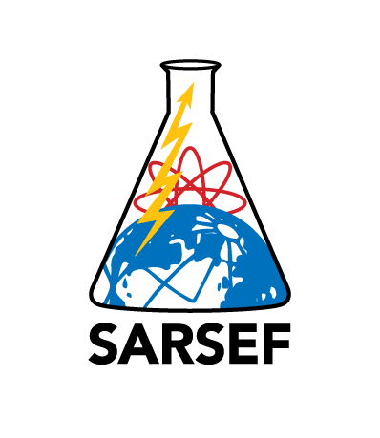

Can you help support the future of Research, Science and Engineering in our community?

March 3, 2016
Tucson Convention Center
7:30 AM to 1:00 Elementary and Middle School Judging
7:30 AM to 4:30 PM High School Judging

75,000 students will complete a project, in the hope of being selected as one of the
top, 5,000 students selected to attend SARSEF.
We need your help to decide who is the best of the best!

Go to: www.sarsef.org and Click on the “Judge” tab

Sign up for the judging assignment that you will most enjoy!

You can choose the grade level you would enjoy judging and then choose the category of science and engineering you are most interested in. We assign you to a judging team so you will not be alone in making a decision. We provide a full breakfast and lunch!

Elementary need to be HS graduates with some interest in science and students. MS judges need a BA or BS and some experience with science/engineering and students. We ask that HS judges have an graduate degree or extensive experience in their field.

Thank you for helping us create excitement and reward students who complete a high quality research project in the fields of Science, Engineering, Math and Technology.

