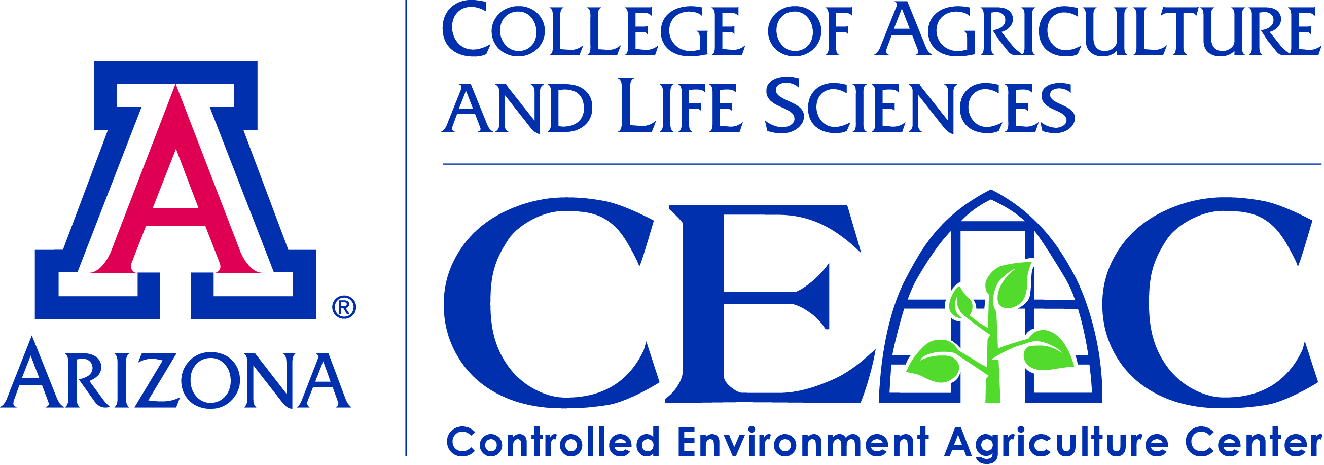
A CEAC Special Seminar
LOCAL ROOTS - THE FUTURE OF FARMING:
INTRODUCING THE WORLD’S MOST ADVANCED VERTICAL FARMS

February 19, 2016 @ 4:00pm
Controlled Environment Agriculture Center, 1951 Roger Rd

Matt Vail, COO Local Roots Farms
Local Roots’ Mission is to improve global health by building a better food system. As industry leaders in CEA and vertical farming, the LA-based company is pioneering technologies to feed the planet healthy and delicious food in environmentally responsible ways.
Join the conversation to learn how Local Roots designs, manufactures, finances and operates modular farms. Compared with traditional farms, Local Roots model enables a 40’ shipping container farm to:
- Grow crops 365 days/year | - Grow anywhere in the world
- Use 97% less water | - Create 50% fewer carbon emissions
- Grow 300x more produce per sq.ft. | - Eliminate pesticide run-off
COO Matt Vail will be presenting the technologies driving the sector including advanced robotics, computer vision, machine learning, and automated control systems. Vail will also share insights about building a disruptive produce company from the ground up.
Whether you are a grower, a technologist, and engineer or simply passionate about sustainable local farming… you don’t want to miss this seminar!
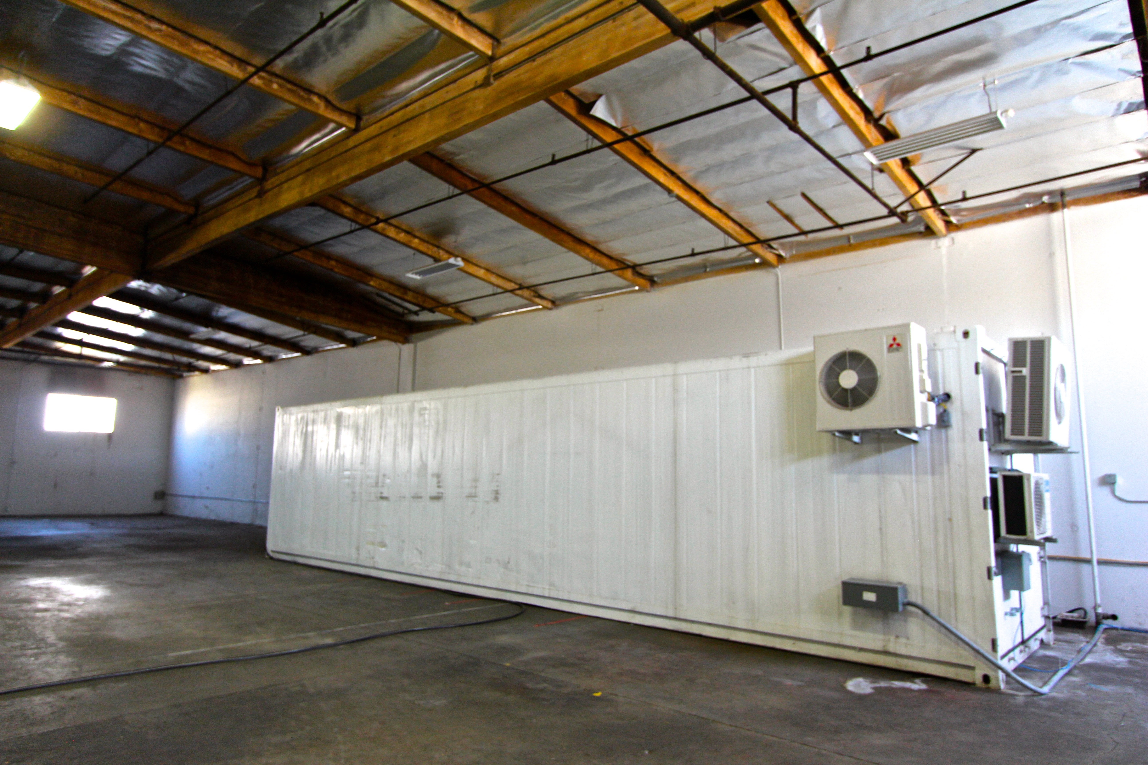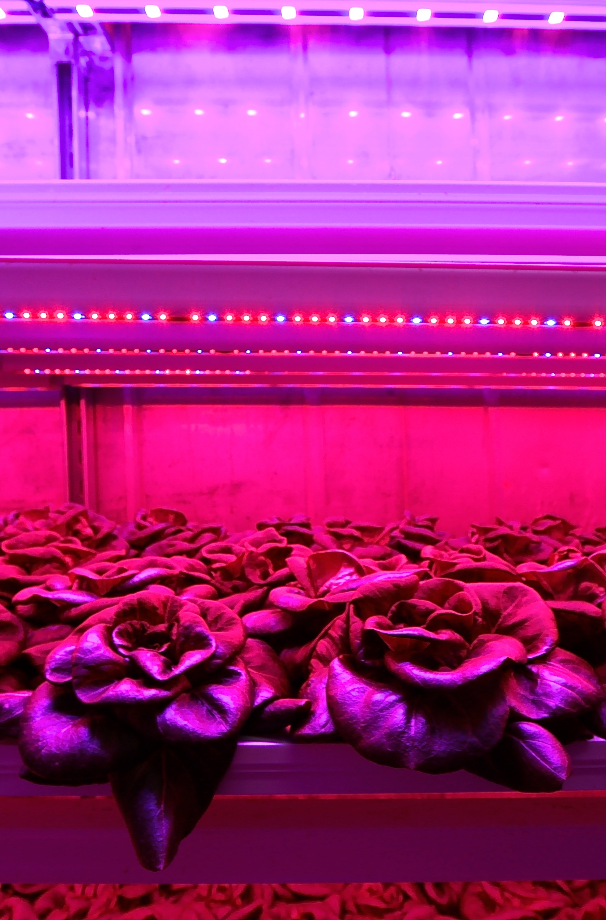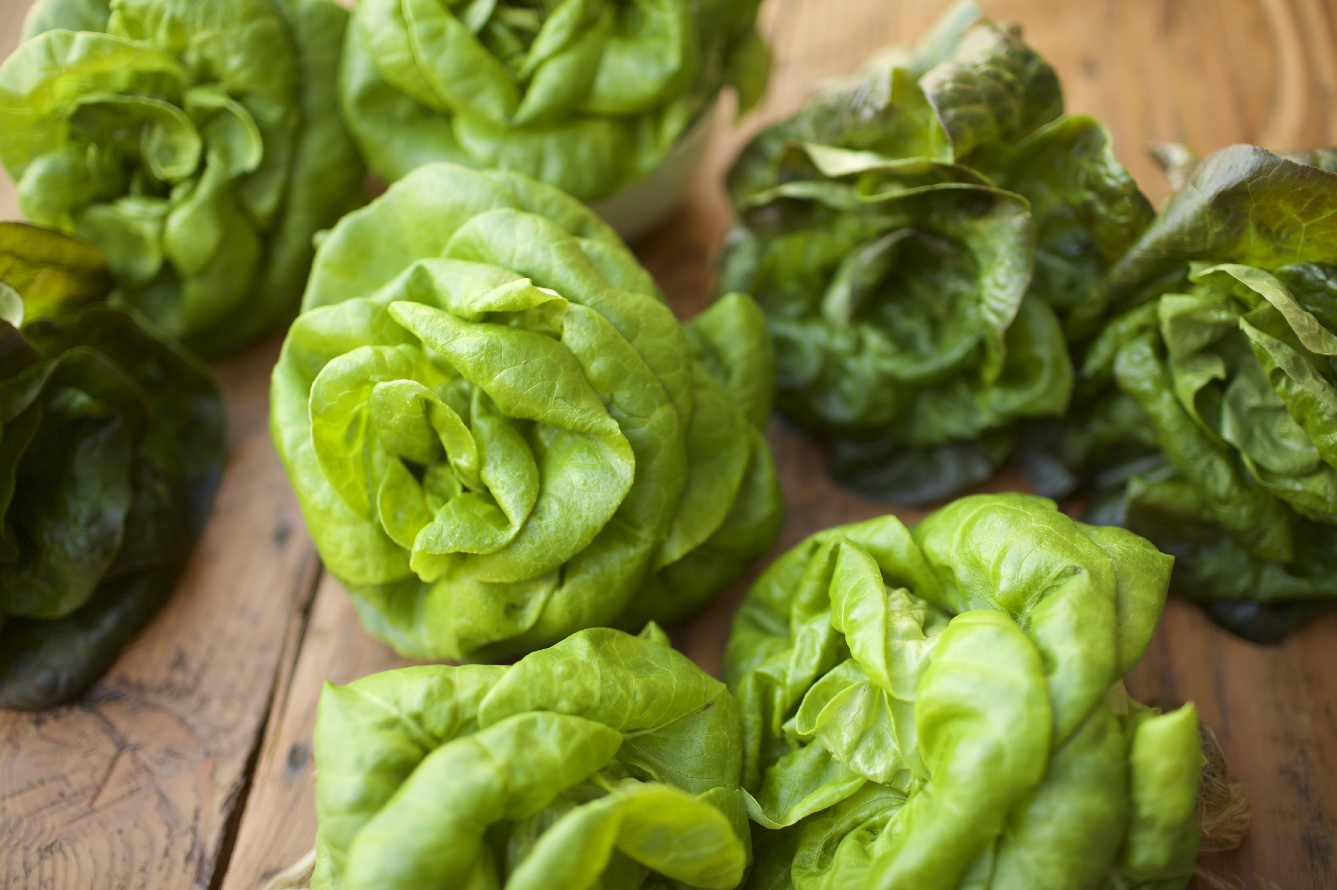
Please visit http://www.localrootsfarms.com or contact info@localrootsfarms.com to learn more about this special opportunity. Now hiring!

