Deadline
Updates to pre-scheduler preloads must be submitted on or before November 15th to be configured by mid-April for the first orientation session.

Prescheduling preloads are being reviewed by the Curriculum Office to ensure consistency with each majors’ published curriculum within Degree Search, the Academic Catalog and Smart Planner. To allow sufficient time for review, please ensure that changes are submitted by the deadline.

- Reviewing prescheduler preload and math configurations and making updates

- Pre-loads

The preload update process has changed this year. The person responsible for your college’s curriculum updates for your college/department will receive an e-mail with the current pre-scheduler configuration and math configuration attached to it.

The attachments are Excel spreadsheets that allow edits. Please do not change the file names of the documents when you download the file.

- After saving the Excel files, open them and determine whether changes are necessary. If no changes are necessary, skip down to the Math Configuration section of this document and review your math configurations.

- If changes are necessary, please do the following:
  - If you would like to delete a course highlight the cells associated with that course in red
  - If you would like to add a course, enter the data in the appropriate cells and highlight the cells associated with the new course in green
  - Changes to existing lines should be highlighted in yellow. Examples are below as are notes about updating pre-loads

A few notes about preloads.
- Academic Department, Student Group, Academic Plan and Academic Subplan are not configurable by departments. If you need to discuss a new build based on a student group, please contact Ryan Windows at rwindows@email.arizona.edu for assistance.
- The Subject and Catalog Number areas allow you to add individual classes (e.g. NSC 102, MIS 111). If you’d like to add a new class in this area just note it in the sticky note and provide a rank for it. If you’d like to remove a class just annotate that it needs to be removed.
- The Gen Ed/Foundation column supports the following entries:
  - Math – specific math classes are detailed on each unit’s math build if one exists. Instructions for updating the math builds are below.
  - English – schedules an English class based on the student’s placement scores
  - Second Language – schedules second language based on a student’s placement scores, transfer credit, CLEP scores, etc. (provided these are in the system at the time of scheduling)
  - TRAD – schedules any Tier 1 TRAD class the student has not already taken
  - NATS – schedules any Tier 1 NATS class the student has not already taken
  - INDV – schedules any Tier 1 INDV class the student has not already taken
  - GEN ED – schedules any ol’ Tier 1 class the student has not already taken

Example before updates:

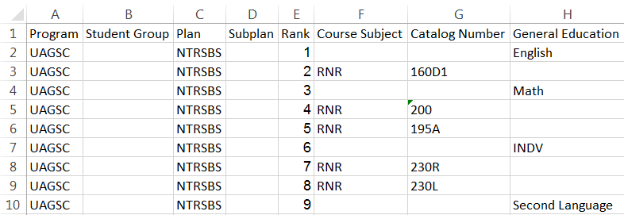

Example with updates completed:

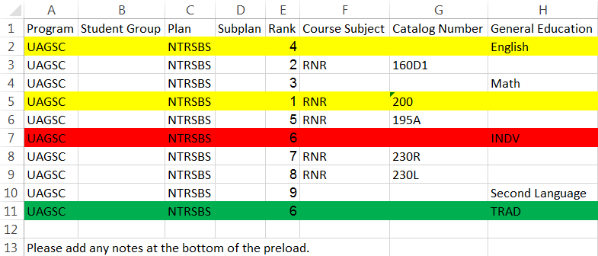

- After all edits have been made on the document, save the changes to the document on your
computer and add the date completed to the document name. (e.g. UAGSC NUSCBS 09172015)

- Math Configuration

If there are math pre-loads associated with the major you’re responsible for, you’ll receive an Excel spreadsheet containing the current configurations. Details regarding how to reach math pre-loads are below:

- Please download the file, save it and review it. If no changes are necessary, please skip to the section of this document entitled ‘Submitting Updates’.
- If changes are necessary, please edit just as you did for your preloads and save it using the same naming convention you did for your preloads (e.g. UAGSC NUSCBS MATH 09172015).

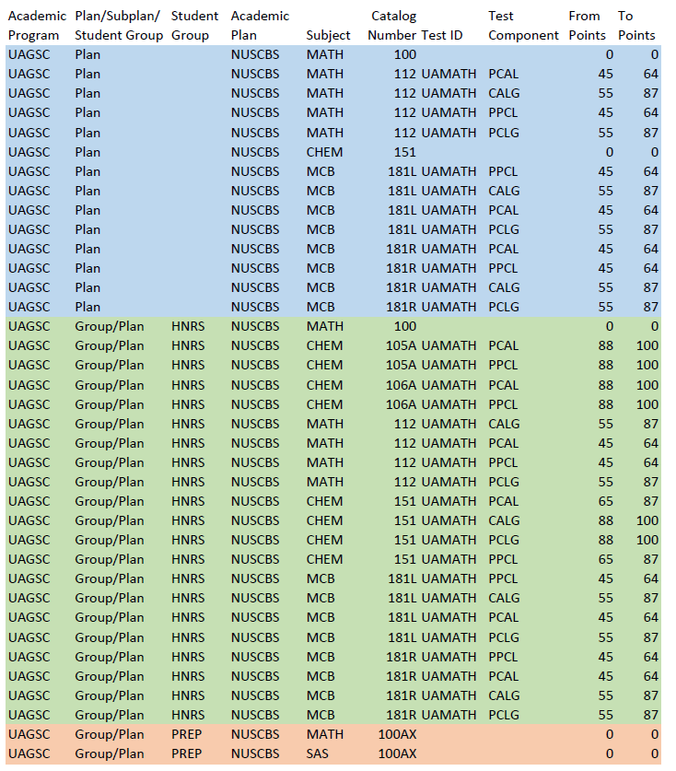

A few notes about math configurations:
- All math configurations are subject to approval by the Math Department so requested changes will be submitted for review before being implemented.
- Math configurations for each college/major contain all classes that depend upon math placement scores for scheduling.
- The scheduling software searches for matches between this file and the student it’s processing in the following order:
  - Student Group/Subplan
  - Student Group/Plan
  - Student Group
  - Program/Plan/Subplan
  - Program/Plan
  - Program
Students can only match on any one of the criteria above so, for example, a NUSCBS student with no HNRS group will be scheduled for the classes in blue, depending upon his/her placement scores, while a NUSCBS student with an HNRS group will be scheduled for classes in green, depending upon placement scores.
- Placement scores on these pages are only used to override published math placements (i.e. to place high scoring Honors students into Chem 105A and 106A). If no placement score is present, as in the case of Math 100, the published Math Department placements are used.

- Submitting Updates

- If no changes are required, please send email to degreerqmtupdates@list.arizona.edu
  - In the subject of the email type enter “PRELOAD – Academic College, Academic Unit, Academic Unit, Academic Unit…”. For Example, “PRELOAD – UAGSC, NUSCBS, VSCBS. (If you’re only responsible for the review of one academic unit, just list that unit. If you’re responsible for the review of multiple academic units, please list all of them).
  - In the body of the email message enter the following information:
    - Name of the person who reviewed the files
    - Name and contact information for the person submitting the approval and to whom questions may be directed.
    - An indication that you have reviewed the files and approved them. (e.g. I am responsible for the departments listed in the subject of this e-mail and have reviewed the scheduler preloads and math configurations which need no changes for this cycle.)

- If changes are required, email the updated preload and/or math configuration documents to degreerqmtupdates@list.arizona.edu
  - In the subject of the email type enter “PRELOAD – Academic College, Academic Unit, Academic Unit, Academic Unit…”. For Example, “PRELOAD – UAGSC, NUSCBS, VSCBS. (If you’re only responsible for the review of one academic unit, just list that unit. If you’re responsible for the review of multiple academic units, please list all of them).
  - In the body of the email message enter the following information:
    - Name of the person who reviewed the files
    - Name and contact information for the person submitting the approval and to whom questions may be directed.
- You will not be contacted about your updates UNLESS there is a problem.

- Help Me!

If you have questions about the preload or math configuration portions of this process, please contact Ryan Windows at 620-621-7938 or rwindows@email.arizona.edu. I’m also available via Lync IM.

