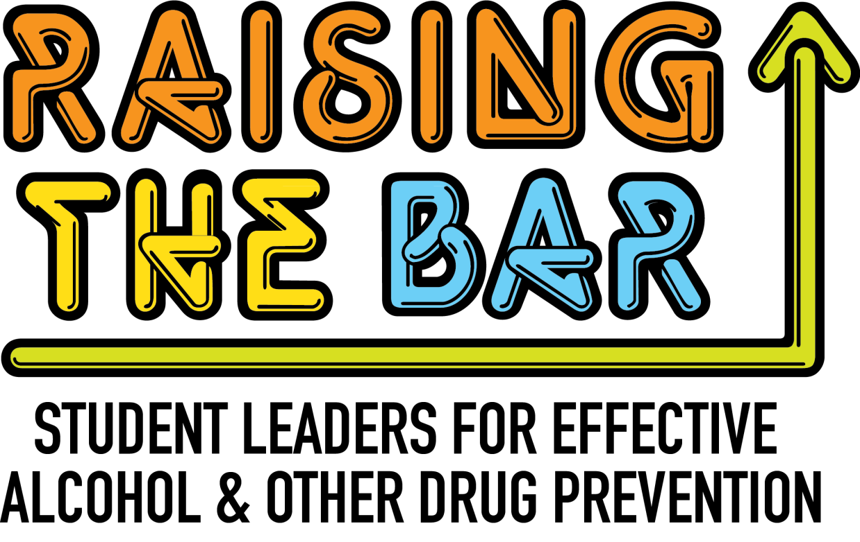

Student Leadership Conference

Saturday, September 19th, 2015 | ASU West – Glendale, AZ | 10am – 5 pm*
*Breakfast snacks & Lunch will be provided
FREE student conference

Network, connect, & share with other students

Learn leadership skills to bring back to your campus

HAVE FUN!

Don’t miss this opportunity to learn, share, connect, and grow among
an amazing group of college student leaders from all over Arizona!

Topics will cover a range of skills and interests,
including how to communicate with peers,
prescription drug misuse, marijuana, creating effective
programming, and more!

REGISTRATION DEADLINE: Friday, September 11th, 2015
TO REGISTER: bit.ly/RaisingTheBar15
Want more information? Contact Christi Clauson at
christiclauson@email.arizona.edu.

