View Transfer Course and Test Credit Rules
Navigation to Transfer Course Credit rules: Records and Enrollment>Transfer Credit Rules>Transfer Subject Area.
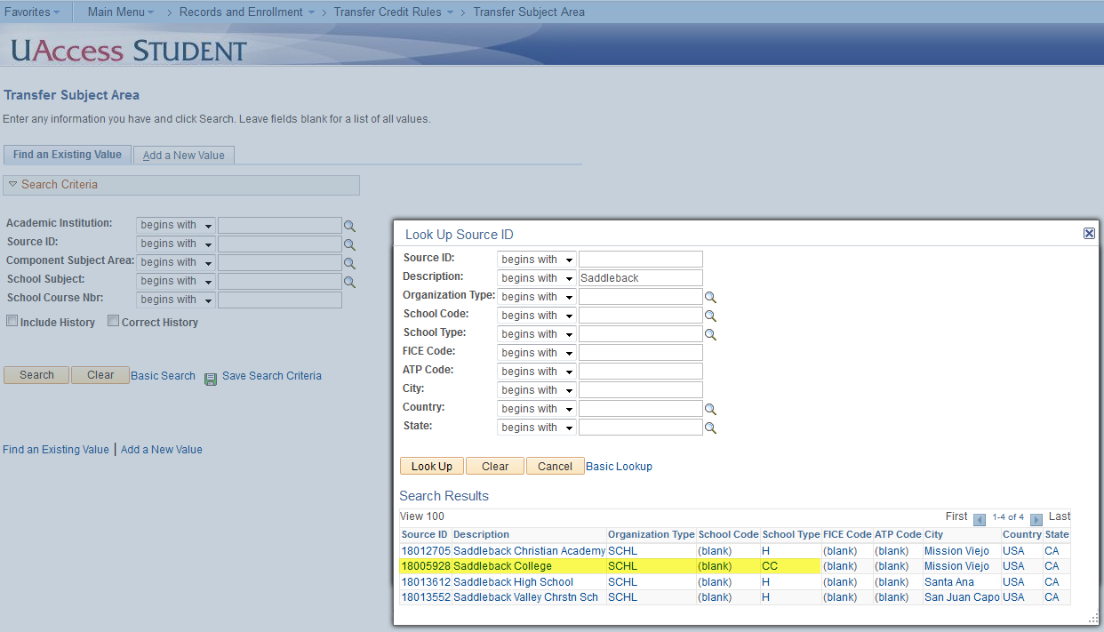
- When viewing Transfer Credit rules you will want to enter the external schools ID in the Source ID box, you can use the look up icon next to the field, to search by name.
- When you have selected the Source ID, if you know the School Subject and School Course Number you are looking for enter it in the appropriate fields.
- If no rules exist you may want to remove the Course Number and run again, as there can be generic rules that do not reference a specific course number.

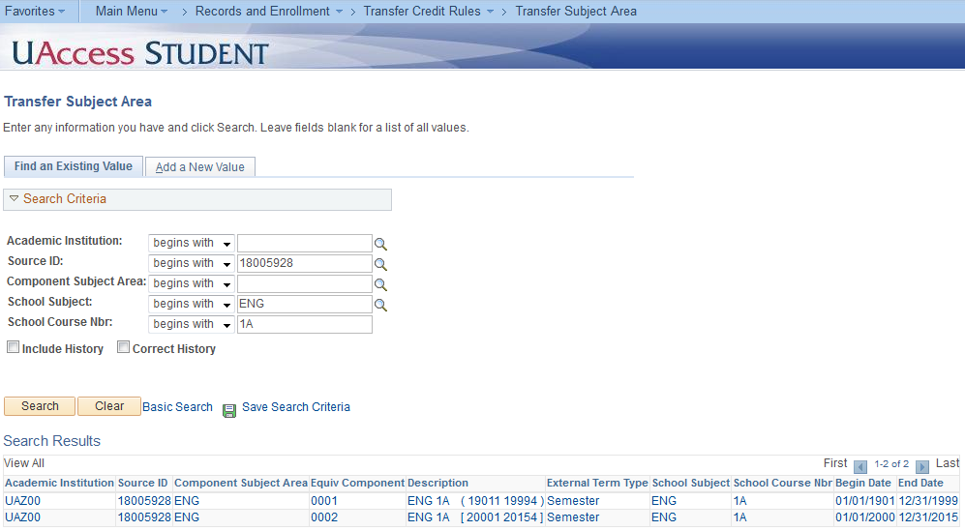
- In the example above there were two rules for this subject and course number, as there are multiple date ranges. You will notice the Begin and End Dates for the first rule are 01/01/1901 to 12/31/1999, this means if the course being brought in was taken during this time it will receive the internal articulation.
- The second rule has a Begin and End Dates of 01/01/2000 to 12/31/2015, so again if the course was taken during this time they will receive the internal articulation.
- To view the Internal articulation click on any one of the Search Results. It will not matter which one, as you will see all results related to the Subject Area.

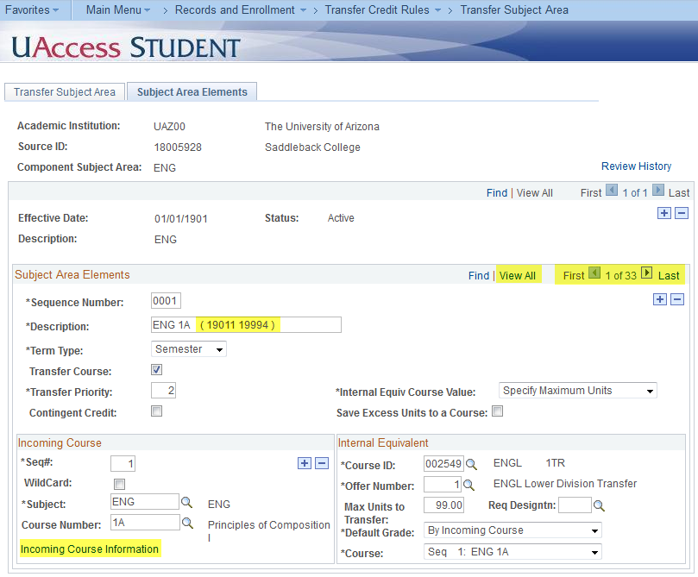
- Select the Subject Area Elements tab, which is where the actual rules are built.
- You will notice there are actually 33 rules with the Subject Area of ENG. The course you are looking for may not always be the first rule, so select View All to display multiple rules at a time.
- Something to note is the rules are not in Course Number order, rather they increment by Sequence Number, so the second rule might be Sequence 2, or Sequence 32.
- We have included the date range in the Description box, but to view the actual date range you can select the Incoming Course Information link. For those that may or may not know, the last digit on the date in the Description box will represent the semester (1 = Spring, 2 & 3 = Summer, 4 = Fall).
- How the course will be articulated to the UA will be entered in the Internal Equivalent box, so for this rule they will receive departmental elective credit. If the Internal Equivalent box is blank this means the course is non transferrable.

Navigation to Test Credit rules is Records and Enrollment>Transfer Credit Rules> Test Transfer Rules.
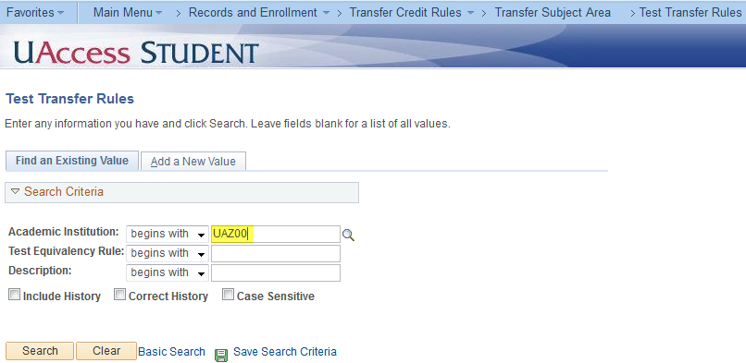
- When viewing Test Credit enter UAZ00 in the Academic Institution field and select Search. You should be taken directly into the list of rules.
- Test credit is different from course credit, as we only maintain one set of rules for exams that receive credit from AP, IB, CLEP and LPE.

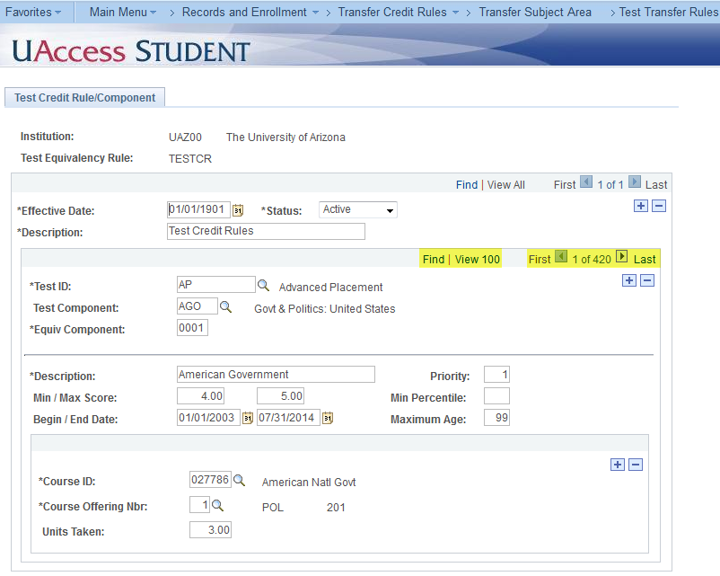
- You will notice there are currently 420 test rules. To help narrow your search, select the Find link, which will pop up a search box. Enter either the Test ID (ex. AP), or if you know the Test Component code (ex. AGO), to search on. Otherwise you will want to click through to find the exam you are looking for.
- You can select View 100, however this can run slow as it has to display quite a bit of data. Again look at the Begin and End Dates to determine if this will be the rule for the exam the student took. You will also notice the Min/Max Score, which you will also want to reference. Directly below it will be the credit the student will receive.

