Agri-SURF
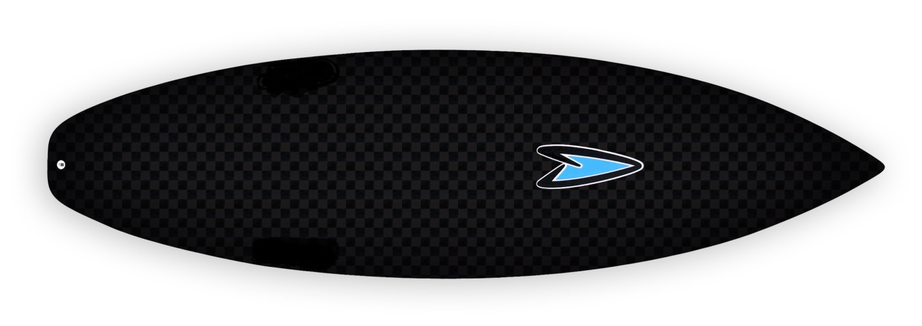
Scholarship Application
Soils 2015

The personal information you give to the Pima AGRI-SURF Fall/Spring Program is kept on file for the federal government (US Department of Agriculture). The information is protected by the Privacy Act. No one may see the information unless they work with or for the Pima ARI-SURF Summer Bridge Program project or are specifically authorized to see the information. The information is necessary to determine if you are eligible to participate in the program and helps the government to measure our success. The Department of Agriculture has the authority to gather information to help make Pima AGRI-SURF Spring/Fall Program a better program. Reasonable accommodations, including materials in an alternative format will be made for individuals with disabilities when a minimum office working day’s advance notice is given. For the general public, please contact the PCC information line at 520.206.4500.
Pima AGRI-SURF Soils Scholarship Application

Pima Community College Desert Vista Campus Northwest Campus
Telephone: (520) 206-5199 email: eesparza1@pima.edu

The Pima Agriculture Sustainability and Universal Renewable Farming Summer Program is funded by the U.S. Department of Agriculture. The program is designed to encourage and prepare students looking to discover the opportunities within the Agricultural career field while attending Pima Community College. All information is strictly confidential and is used solely for the purpose of determining eligibility of students applying for participation in the Sustainable Plant Systems Summer Program.

STUDENT INFORMATION

Last Name:_________________________________ First Name: ___________________M.I.___
Mailing Address:_____________________________________ City: ___________Zip: ________
Student Cell Phone: (_____)_________________ Email: ________________________________
Gender: Female Male Age:________

Student’s Ethnic Background:
Hispanic/Latino American Indian or Alaskan Native White Asian
African American Native Hawaiian or Other Pacific Islander More than one race

PIMA COMMUNITY COLLEGE INFORMATION

PCC Classification: Incoming Freshmen Sophomore Other
PCC Student ID Number (A-number): ________________________________________________
What is your intended field of study at Pima Community College or other university:

________________________________________________________________

SIGNATURE

I hereby understand all that is required by me from the Agri-SURF Soils Scholarship Program and will follow the direct guidelines to the best of my ability.

_____________________________________________________________________________________
Student’s Printed Name Student Signature Date



Pima Agri-SURF Soils Program 2015
Desert Vista Campus

