Deadline
Updates to pre-scheduler preloads must be submitted on or before December 15th to be configured by mid-April for the first orientation session.

Beginning with the 2015 – 2016 pre-scheduling cycle, prescheduling preloads are being reviewed by the Curriculum Office to ensure consistency with each majors’ published curriculum within Degree Search, the Academic Catalog and Smart Planner. To allow sufficient time for review, please ensure that changes are submitted by the deadline.

- Reviewing prescheduler preload and math configurations and making updates

- Pre-loads

The preload update process and curriculum update processes have been consolidated, so you will find scheduling preloads and math configuration on the same pages you use to update your curriculum:

http://confluence.arizona.edu/display/DRU/Curriculum+Updates+for+2015-2016

The main page displays the colleges that offer undergraduate majors. Each college page is broken into sections by academic unit, and these sections will contain the corresponding scheduling files if they exist for the major.
- Select your college from the list provided on the page:

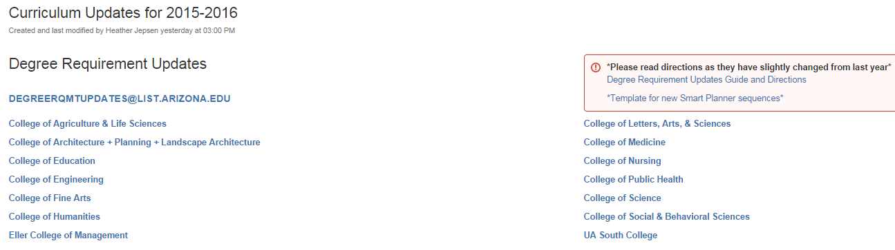

- Select each major and college preload you’re responsible for maintaining:

If your major(s)/college(s) look like this:

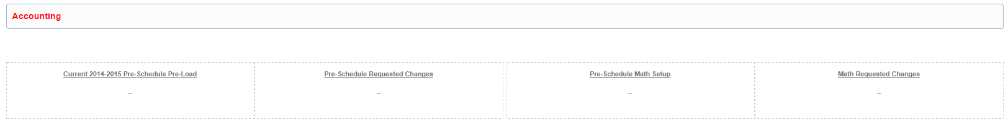

Congratulations, you’re done! That means students in your major are scheduled using your college’s pre-load and math configuration and the person responsible for your college’s curriculum will make any updates. If you wish to add a scheduling preload for your specific student population, please speak with the person responsible for your college’s curriculum and have them submit this form: http://confluence.arizona.edu/display/SATEAM/New+Prescheduler+Preload+Request

If your major(s)/college(s) look like this:

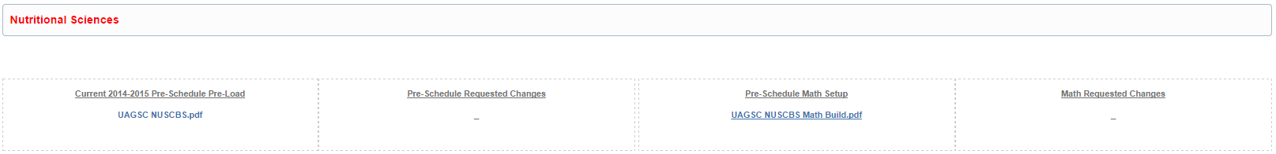

In the ‘Current 2014-2015 Pre-Schedule Pre-Load’ column, all current 2014-15 preload configurations are listed. Please save the PDFs to your local computer. Review each the pre-load configuration and indicate any updates for the 2015 – 2016 scheduling cycle. The preloads are in a PDF format that
allows edits to be made within the documents. Please do not change the file names of the documents when you download the file.

- After saving the PDF, open the document in Acrobat Reader and determine whether changes are necessary. If no changes are necessary, skip down to the Math Configuration section of this document and review your math configurations.

- If changes are necessary, click on ‘Comment’ in the toolbar. This will open the editing toolbar. The preferred method of editing is by inserting electronic sticky notes next to items that require updates. **NOTE: If you don’t have a ‘Comment’ item available to you when you’re viewing the document, you’re likely viewing it in your web browser. Locate Adobe Reader on your computer and open the file with that program. If you still don’t have the ‘Comment’ item after opening the file in Reader, try downloading the latest version from here http://get.adobe.com/reader/

- Place your cursor on the item that you would like to update and click on the sticky
note icon. A sticky note box will open and you can note updates for that Item in the
box. The note will be directly related to the site where you placed your cursor. All sticky
notes are viewable for reference.

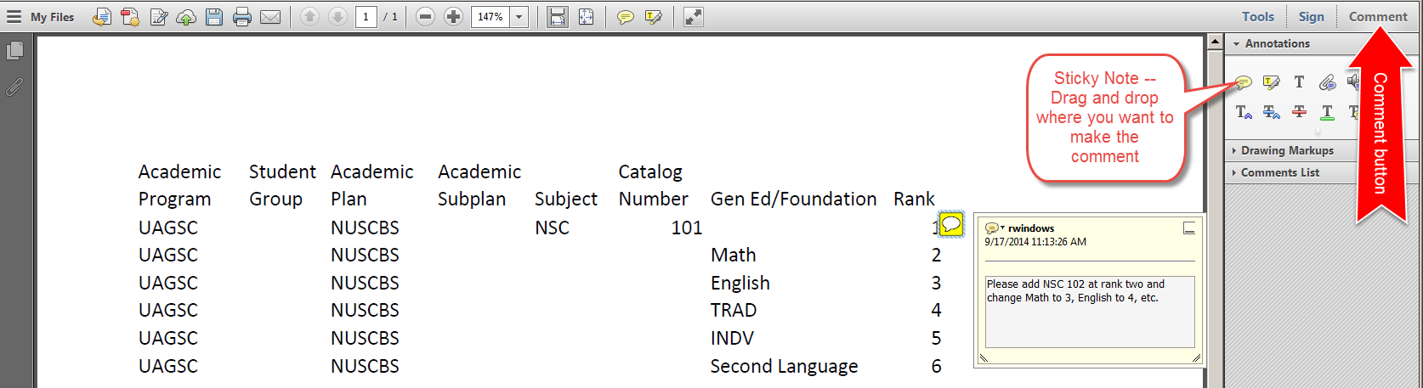

A few notes about preloads.
- Academic Department, Student Group, Academic Plan and Academic Subplan are not configurable by departments. If you need to discuss a new build based on a student group, please contact Ryan Windows at rwindows@email.arizona.edu for assistance.
- The Subject and Catalog Number areas allow you to add individual classes (e.g. NSC 102, MIS 111). If you’d like to add a new class in this area just note it in the sticky note and provide a rank for it. If you’d like to remove a class just annotate that it needs to be removed.
- The Gen Ed/Foundation column supports the following entries:
  - Math – specific math classes are detailed on each unit’s math build if one exists. Instructions for updating the math builds are below.
  - English – schedules an English class based on the student’s placement scores
  - Second Language – schedules second language based on a student’s placement scores, transfer credit, CLEP scores, etc. (provided these are in the system at the time of scheduling)
  - TRAD – schedules any Tier 1 TRAD class the student has not already taken
  - NATS – schedules any Tier 1 NATS class the student has not already taken
  - INDV – schedules any Tier 1 INDV class the student has not already taken
  - GEN ED – schedules any ol’ Tier 1 class the student has not already taken

- Add a new sticky note for each item being updated by moving your cursor and
adding additional sticky notes.
- After all edits have been made on the document, save the changes to the document on your
computer and add the date completed to the document name. (e.g. UAGSC NUSCBS 09172014)

- Math Configuration

In the ‘Pre-schedule Math Setup’ column, all current 2014-15 math configurations are listed.

- Please download the file, save it and review it. If no changes are necessary, please skip to the section of this document entitled ‘Submitting Updates’.
- If changes are necessary, please edit it using sticky notes just as you did for your preloads and save it using the same naming convention you did for your preloads (e.g. UAGSC NUSCBS 09172014).

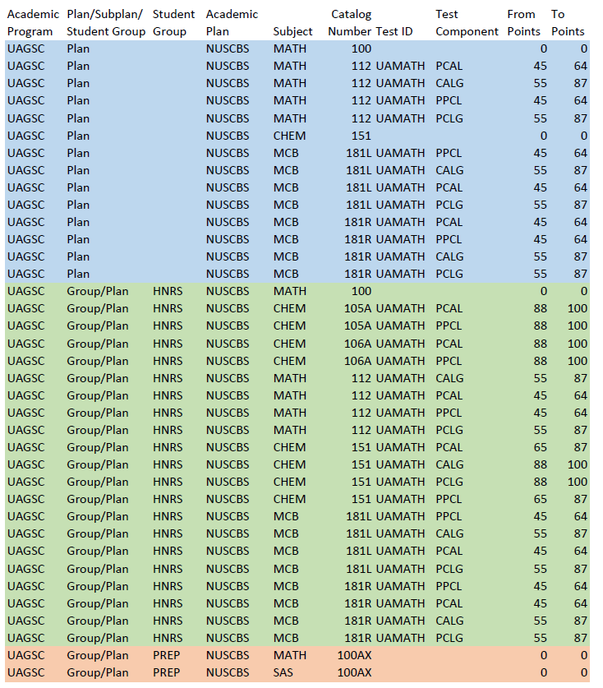

A few notes about math configurations:
- All math configurations are subject to approval by the Math Department so requested changes will be submitted for review before being implemented.
- Math configurations for each college/major contain all classes that depend upon math placement scores for scheduling.
- The scheduling software searches for matches between this file and the student it’s processing in the following order:
  - Student Group/Subplan
  - Student Group/Plan
  - Student Group
  - Program/Plan/Subplan
  - Program/Plan
  - Program
Students can only match on any one of the criteria above so, for example, a NUSCBS student with no HNRS group will be scheduled for the classes in blue, depending upon his/her placement scores, while a NUSCBS student with an HNRS group will be scheduled for classes in green, depending upon placement scores.
- Placement scores on these pages are only used to override published math placements (i.e. to place high scoring Honors students into Chem 105A and 106A). If no placement score is present, as in the case of Math 100, the published Math Department placements are used.

- Submitting Updates

- If no changes are required, please send email to degreerqmtupdates@list.arizona.edu
  - In the subject of the email type enter “PRELOAD – Academic College, Academic Unit, Academic Unit, Academic Unit…”. For Example, “PRELOAD – UAGSC, NUSCBS, VSCBS. (If you’re only responsible for the review of one academic unit, just list that unit. If you’re responsible for the review of multiple academic units, please list all of them).
  - In the body of the email message enter the following information:
    - Name of the person who reviewed the files
    - Name and contact information for the person submitting the approval and to whom questions may be directed.
    - An indication that you have reviewed the files and approved them. (e.g. I am responsible for the departments listed in the subject of this e-mail and have reviewed the scheduler preloads and math configurations which need no changes for this cycle.)

- If changes are required, email the preload and/or math configuration documents to degreerqmtupdates@list.arizona.edu Please note, only PDF files will be accepted for update requests. Email requests without a PDF will be returned with directions to return to the website and add comments to the PDF there. All updates MUST be sent to degreerqmtupdates@list.arizona.edu
  - In the subject of the email type enter “PRELOAD – Academic College, Academic Unit, Academic Unit, Academic Unit…”. For Example, “PRELOAD – UAGSC, NUSCBS, VSCBS. (If you’re only responsible for the review of one academic unit, just list that unit. If you’re responsible for the review of multiple academic units, please list all of them).
  - In the body of the email message enter the following information:
    - Name of the person who reviewed the files
    - Name and contact information for the person submitting the approval and to whom questions may be directed.
- Unlike the curriculum update process, you will not be contacted about your updates UNLESS there is a problem.

- Help Me!

If you have questions about the preload or math configuration portions of this process, please contact Ryan Windows at 620-621-7938 or rwindows@email.arizona.edu. I’m also available via Lync IM.

