College of Agriculture and Life Sciences
On-line Degree Audit process
Steps for CALS students:
- Student is made eligible to apply for graduation and is notified by email that they may apply if they have 90 completed units or more. A message will also display indicating if they have fewer than 30 units to complete degree requirements to proceed with the steps.
- Two checklist items are created for the student, “Apply for Graduation,” and “Contact Advisor”
- Student applies online. The “Apply for Graduation” checklist item is completed
- The student will receive a second email with instructions to contact their academic advisor to complete the degree audit worksheet. The major advisor will fill out the degree audit worksheet (pink sheet) and attach an advisement report (ADVIP) to the degree audit form and sign it. Major advisor will also provide students with the college and department surveys. The major advisor will keep the department survey and give students the signed degree audit worksheet, ADVIP and college survey. *Please print ADVIP with 2 sheets per page double-sided
- If the student has a minor and the ADVIP lists it as ‘not satisfied’ refer them to their minor advisor
- Make students aware that they will also need an honors advisor signature if they plan to graduate with honors. Refer them to the Honors College at the Slonaker House, if applicable
- Once students obtain the major, minor (if applicable), honors (if applicable) they submit the degree audit with college survey to Nancy Rodriguez-Lorta or Kristen Geary in Forbes Room 211 (or Saguaro Hall 221 during Spring 2015) to sign on behalf of College Dean. If they do not have the college survey attached they will have to fill it out prior to submitting degree audit worksheet. Maria Bueno will scan the degree audit worksheet and email it to the designated major advisor and student
- Once signed the degree audit will be given to Julie Adkins, Graduation Services advisor, for final auditing. Student plan stack will be listed as ‘in review’
- The “Contact Advisor” checklist item is completed and removed from the students UAccess Student Center
- The Graduation Services Advisor reviews the Degree Audit Worksheet and ultimately posts the degree

*“Pink Sheet” = Degree Audit Worksheet
UAccess Student Center:
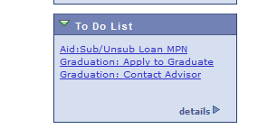
Where advisors can check student’s status (eligible, applied, in review):
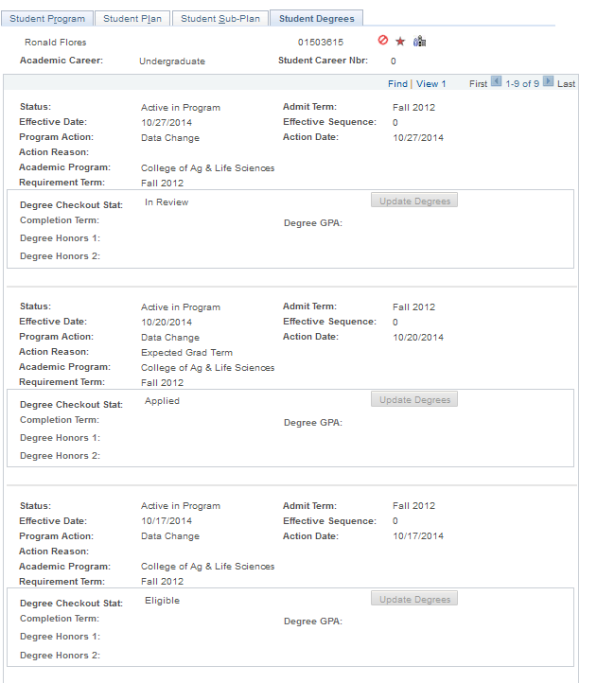
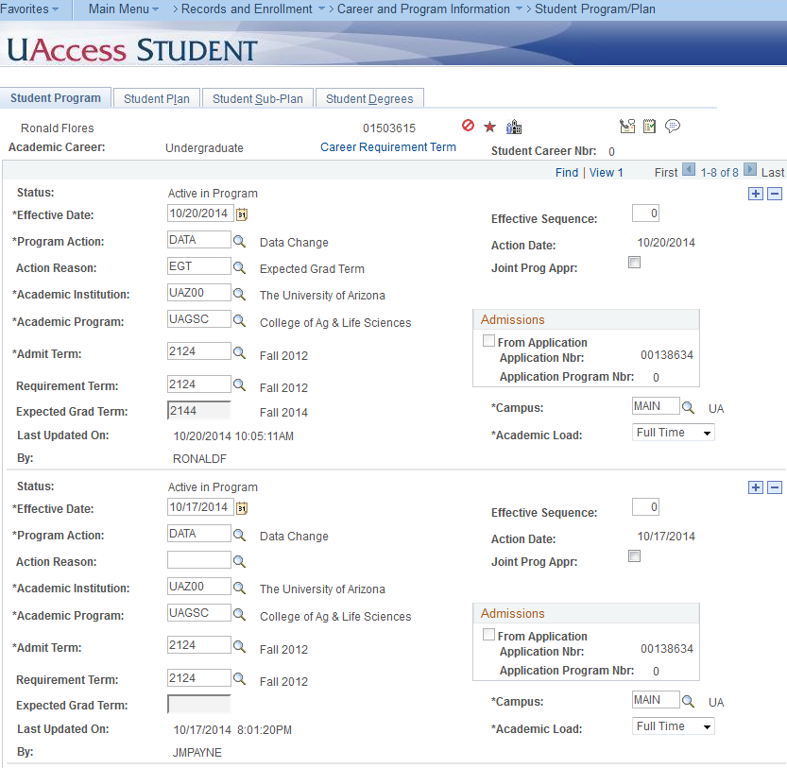

Analytics Report for advisor use:
Student report can be run by department. The Degree Checkout Status will list the following:
- Applied for Graduation = applied online
- Program in Review = degree audit worksheet is received by Julie Adkins, Graduation Services advisor. She will code the degree audit worksheet
- Needs to Finish Pending Work = currently on report for students that have filed paper application; it won’t be a status for the online applicants

THREAD: Dashboards – Student Degrees – Expected Graduation
