  
  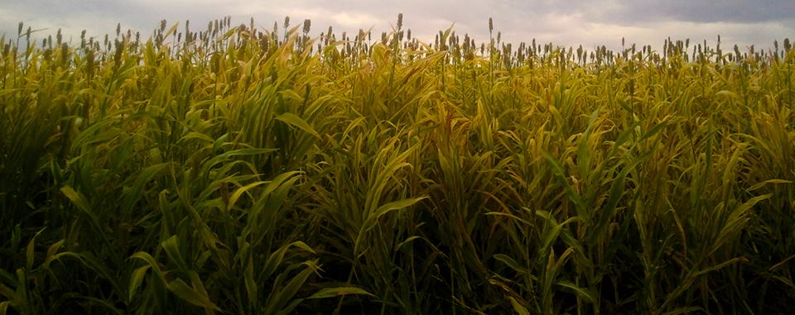
    - May 2, 2014
  Agricultural and Biosystems Engineering
  Open House
  Come learn what our
  Biosystems Engineering
  majors and minors degrees have to offer!
  Friday May 2nd Shantz 440
  4:00 pm
  Meet our Professors
  and
  Advisors!
  Discover Biosystems Engineering!
  Majors and Minors!
  