Using the Online Advisement Report to Enter Course Directive Exceptions

Creating course directive exceptions from the online advisement report saves time and eliminates the need to gather disparate pieces of information: requirement term, career, program, plan, sub-plan, and student ID information on the first page of the exception; and requirement group, requirement, and line numbers on the second page of the exception.

Navigation: Academic Advisement > Student Advisement > Request Advisement Report
Step | Action
1. | Generate an ADVIP advisement report for the student you need to enter exceptions for.
2. | Scroll to the area of the advisement report you want to make an exception to.

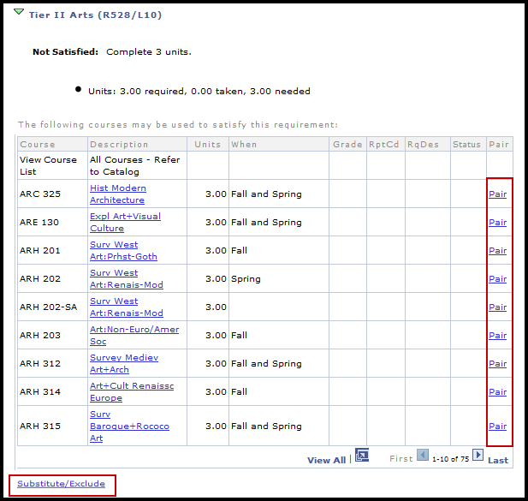

3. | Notice that next to each course is a “Pair” link and below the course list is a “Substitute/Exclude” link.  - Pair: Clicking the Pair link will create a course directive exception that excludes the course associated with the link you clicked. The exception will also generate a line for you to choose which course you want to direct to the line.  - Substitute/Exclude: Clicking Substitute/Exclude will create a course directive exception that allows you to substitute or exclude a course. No course is paired with the exception automatically if you choose this option.
4. | For this example, we click on the ARH 315 Pair link. A new UAccess window automatically opens to the exceptions page.

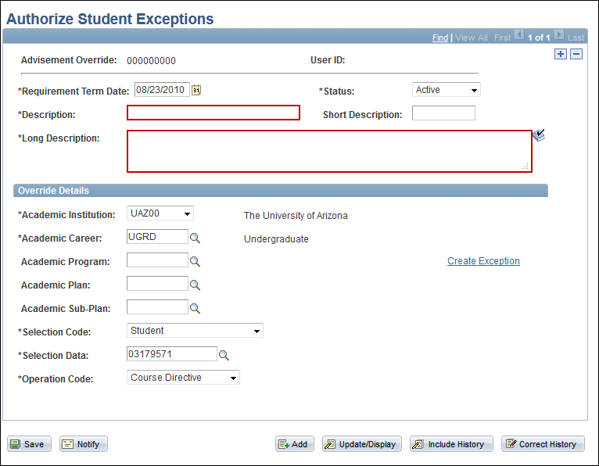

Step | Action
5. | Notice that the Requirement Term Date, Career, and Selection Data fields are automatically filled out for you. The Description and Long Description fields are both required. None of the items under “Override Details” need to be input. If a major or sub-plan is chosen that information will also populate for you (please see upcoming example).  Note: the Description does not appear on the advising report; however, if searching for an exception via description this is the field it will search, and this is also the description that appears in the search results. The Long Description does appear on the online advising report, so use it to include pertinent data regarding your exception. Examples include the date you enter the exception, name of transfer course, reason for exception, etc.
6. | Once you have input your Description and Long Description click Create Exception.

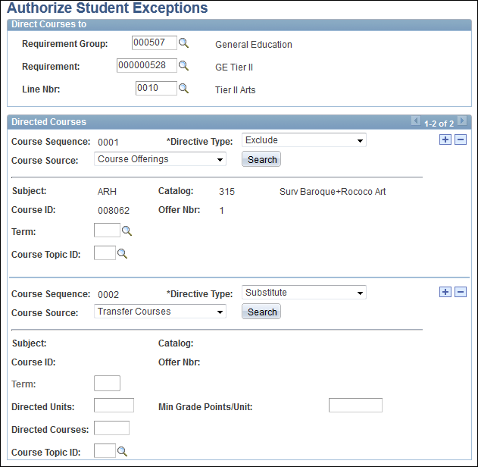

Step | Action
7. | Notice that the requirement group, requirement, and line numbers have auto-filled for you. Further, ARH 315 is already set to exclude. Now you just need to select your Course Source for the Substitute and choose the appropriate course for your exception.  Note: Even though the Pair link automatically excludes the course you select it does not automatically pair them on the “Course Replacement Maintenance” screen. You must still do that manually.
8. | Once you have completed and saved your exception you can simply close the UAccess window and return to the advisement to enter more exceptions or to refresh the report.  To enter more exceptions just follow the same process by clicking Substitute or Pair where you want to enter you exception. Please note that new exceptions won’t appear on the advising report until you have refreshed it.  To refresh the advising report scroll to the bottom of the report and click on “Return to Report Request.” Next, click “Process Request” to generate a new online advising report that will be up to date with the exceptions you just made.
9. | The process works the same when using the Substitute/Exclude link. The only difference is you don’t have a course that is automatically excluded.

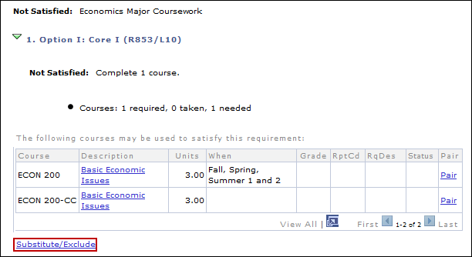

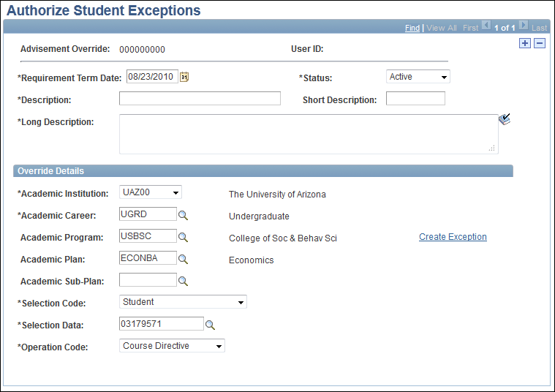

Step | Action
10. | Notice how this time the program and plan information pulls in to the exception since it is needed for an exception to the major.

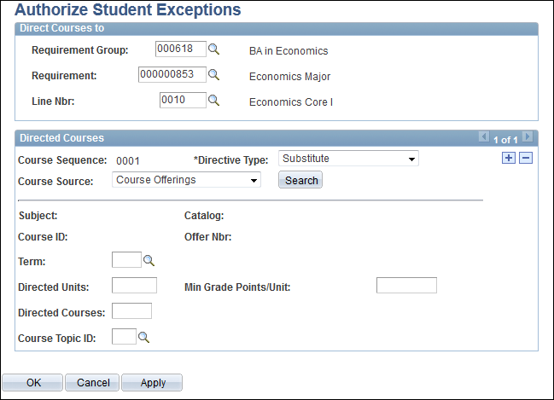

Step | Action
11. | Once you click Create Exception you’ll see that, again, the requirement group, requirement, and line number have all populated with the correct information. However, no course is automatically excluded. At this point you are ready to substitute or exclude courses to the line.

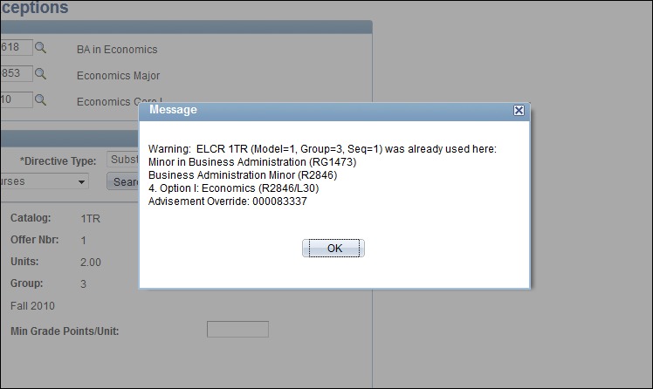

Step | Action
12. | If the course (i.e. course offering, enrollment, test, or transfer) is already being used in an active exception you will get a warning message telling you where the course has already been used and what the corresponding advisement override number is. This is just a warning, so you can still click okay and save your exception and have it apply to the advising report.  If you do not want to use the course in your exception you can either select a different course or delete the exception.  Note: This warning references the advising report and searches for exceptions that are being applied to the advising report. So if you are inputting multiple exceptions at once without refreshing the report you will not see this error, nor will you see this warning if the course was used in an exception that is not being applied (e.g. the course was used in an exception to a major that the student dropped).

