Module: | Academic Advisement
Business Process Name: | Academic Agreements
Created By: | Brad Hensley
Creation Date: | May 21, 2013

Table of Contents

The Probation Process & Academic Agreements . . . . . . . . . . . . . . . . . . . . . . . . . . . . . . . . . . . . . . . . . . . . . . . . . . . . . . . . . 2

Requesting Security . . . . . . . . . . . . . . . . . . . . . . . . . . . . . . . . . . . . . . . . . . . . . . . . . . . . . . . . . . . . . . . . . . . . . . . . . . . . . . . . 3

Setting Up Academic Agreements . . . . . . . . . . . . . . . . . . . . . . . . . . . . . . . . . . . . . . . . . . . . . . . . . . . . . . . . . . . . . . . . . . . . . 4

Viewing Academic Agreements . . . . . . . . . . . . . . . . . . . . . . . . . . . . . . . . . . . . . . . . . . . . . . . . . . . . . . . . . . . . . . . . . . . . . . 9

Academic Agreements in Student Center . . . . . . . . . . . . . . . . . . . . . . . . . . . . . . . . . . . . . . . . . . . . . . . . . . . . . . . . . . . . . . 12

College Default Values . . . . . . . . . . . . . . . . . . . . . . . . . . . . . . . . . . . . . . . . . . . . . . . . . . . . . . . . . . . . . . . . . . . . . . . . . . . . 15

Availability of Academic Agreements . . . . . . . . . . . . . . . . . . . . . . . . . . . . . . . . . . . . . . . . . . . . . . . . . . . . . . . . . . . . . . . . . 17

The Probation Process & Academic Agreements:

Grace Period at the end of the Fall and Spring semesters:
The academic agreement grace period begins once the advising directors for each college have completed their review of the probation report. At this point in time advisors may go and create an academic agreement for any students for whom they want to create an academic agreement for the upcoming term. It is not mandatory for an advisor to create an agreement for a student on probation; if no Academic Agreement is manually created the student will receive an auto-generated containing the college’s default messaging / values.

Academic Agreements created during the grace period for the forthcoming term will not be viewable by students until the grace period concludes. The grace period will last approximately 1-2 weeks. The Advising Resource Center will notify the UITS Academic Advising – Student Administration team when agreements for the new term should be made available to students.

Academic Agreement (AGR) Service Indicator:
Shortly after the conclusion of the grace period an AGR service indicator will be placed on all students who are on academic probation indicating they have an Academic Agreement available to access. The AGR service indicator will have no impact on students; it is merely there to help identify students who are on academic probation. The AGR service indicator will be released at the end of the semester for students who are no longer on academic probation.

Messaging:
At the same time the AGR service indicator is placed on students an electronic communication will be sent to students notifying them of their probationary status and instructing them how to access their academic agreement in Student Center.

Student Access of Academic Agreements:
Students with an Academic Agreement can access it from two locations in Student Center. The first is by selecting “Academic Agreements” from the drop-down menu on the main Student Center page. The second is by going to their “My Academics” page in Student Center and clicking the “View My Academic Agreements” link.

When students access the Academic Agreement from Student Center UAccess will look to see if the student has an Academic Agreement on file for the approaching Fall or Spring semester (i.e. agreement manually created by an advisor, agreement that spanned multiple terms, or previously viewed auto-generated agreement). If a student has an existing agreement that agreement will display to students. If no Academic Agreement is on file for the term and the student is on probation then UAccess will auto-generate an Academic Agreement that will populate with conditions as determined by their college.

If a student changes his/her program (college) during the semester and returns to the Academic Agreement page UAccess will check to see if an agreement exists for the new program. If one does exist, the student will see that agreement added available agreements; if no agreement exists for the new program a new, auto-generate agreement will be created and included on the Academic Agreement page for viewing The advisor will also have the opportunity to manually create an Academic Agreement for the new program/plan.

Students in multiple programs (i.e. double degree students) will receive an Academic Agreement for each program.

Students who go to the Academic Agreement page and are not on probation and do not have any previous Academic Agreements will receive a message indicating no Academic Agreements are on file. If the student is off of probation but has previous agreements those will display for the student to review, should they choose to do so.

Deletion of Academic Agreements:
Mistakes happen. If you create an academic agreement in error or that contains significant mistakes please contact the Advising Resource Center or the Academic Advising Business Analysts in UITS on the Student Administration team.

Requesting Security:
There are varied levels of security for Academic Agreements. This is to ensure that advisors and staff have the appropriate level of access to the Academic Agreements based on their responsibilities and college/departmental advising structure.

Security may be request using the Access Provisioning Tool: https://request.uaccess.arizona.edu/uaccess_appreq/

All roles can be located under the following navigation in the Access Provisioning Tool:
UAccess Student – Campus Users > Academic Advising

Academic Agreement View:
This role allows users to view academic agreements on both the Advising menus and in Student Services Center. Users with this role cannot create new or update Academic Agreements.

Academic Agreement Update:
This role allows users to create new Academic Agreements. Users receiving Advisor Notes Update security will also receive Academic Agreement Update permission. Users receiving this role also receive the same privileges contained in the Academic Agreement View role.

Academic Agreement Coordinator:
This role allows users to set up the program (college) default values for Academic Agreements. This role should be requested for Advising Coordinators/Directors in each college. This role is also included in the Academic Advising College Director composite.

Setting Up Academic Agreements:

Creating New Agreements:
For those who have the security to do so, new Academic Agreements may be set up at Main Menu > Academic Advisement > Student Advisement > Academic Agreement > Add A New Value.

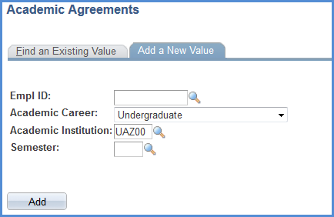
You may input a term in the semester box, but it is not required.

The EMPLID (Student ID) field is required. The academic career defaults to Undergraduate but could be changed if needed. The Academic Institution will always be UAZ00.
The “Eff Term Begin” and “Eff Term End” are required. These will be populated if a term is input on the “Add A New Value” tab. The Eff Term End defaults to the same term as the Eff Term Begin but may be changed to allow the agreement to carry over multiple terms.
Academic Agreement:
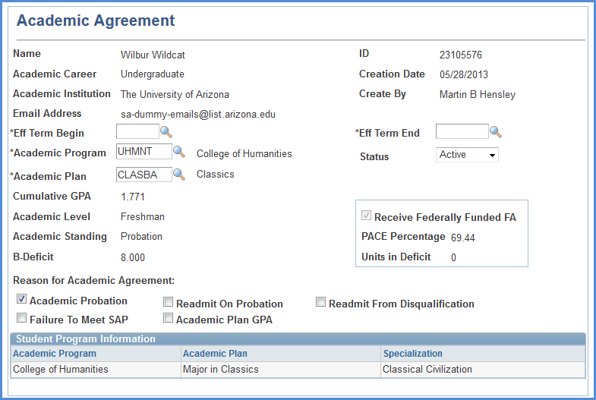
The “Program” and “Plan” will default to the student’s primary program/plan, but they may be changed as needed.
If the student receives federal financial aid, their PACE percentage and units in deficit will display here.

Cumulative GPA, Academic Level and Standing, and B-Deficit will also populate automatically.
Agreements may be set as Active or Inactive. An agreement might be made “inactive” if the student changes colleges, for example.
Basic information will automatically populate on the agreement.

The agreement will default to “Academic Probation” but other options may be chosen as desired.
Student Program Information will display the student’s current Program/Plan information. This information will change if a student’s CPP data changes (i.e. changes program or plan, adds a new plan, etc.)

B-Deficit:
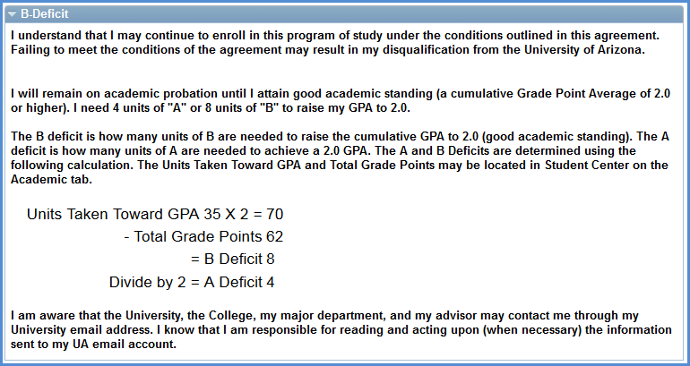
The following message will display along with the student’s B-Deficit calculation. If the student’s B-Deficit is 0 this will display on the Academic Agreement set up page but will not display to students. None of this information can be edited.

The following sections of the Academic Agreement are optional but can be used to better customize the Academic Agreement for the student.

Conditions:
Conditions may be added to the agreement by checking the box next to the desired condition. If you check a condition that requires additional data please be sure to include that information in the appropriate box. Only Conditions that are checked will be visible to students. This section may be pre-populated if the student’s college has identified default conditions to appear on the agreement. You can update these conditions as you deem appropriate.
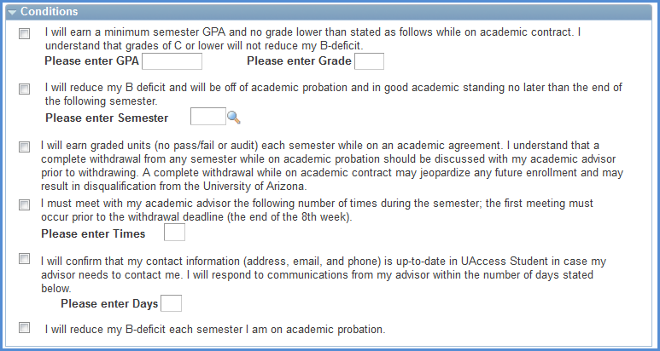

Academic Plan:
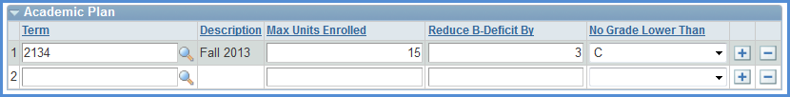
The Academic Plan allows you to make a semester by semester plan for the student. The data included here has no bearing on the student’s record, so the “Max Units Enrolled” does not impact his/her registration. You may add a new row by clicking the button.

Course Plan:
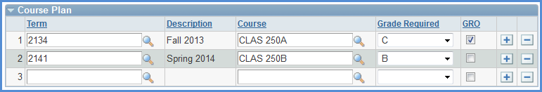
The Course Plan allows you suggest courses for the student for upcoming terms. You can add multiple courses to the same term or suggest courses for multiple terms. You may also check the GRO box if you want to recommend the student GRO a particular course.

Recommendations From Academic Advisor:
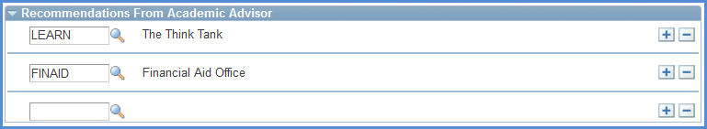
The Recommendations From Academic Advisor section allows you to refer the student to other campus offices and resources that may be beneficial for the student. These are the same values that may be chosen from the “Referral” field on Advisor Notes.

Advisor Additional Stipulations:
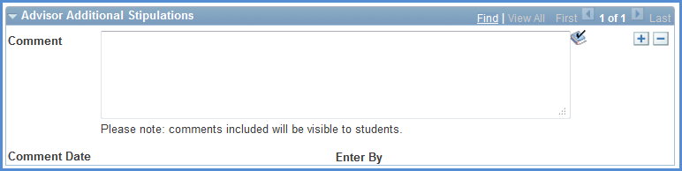
Advisor Additional Stipulations provides you with a text box where you can include any comments, information, or stipulations you desire, that are not covered elsewhere on the Academic Agreement. Please note, students will be able to see what is input in to this section. The comment will also be user and date stamped.
Special Note: When an Academic Agreement is “accepted” by either the student or the advisor the agreement locks and none of the values may be changed except the Advisor Additional Stipulations. So, if you ever need to update an existing Academic Agreement that has been locked please do so by clicking and adding a new comment to the agreement. Once you are done, please Save the agreement for the comment to be viewable by the student. If more than one Advisor Additional Stipulation exists you will need to use the navigation arrows to view it.

College Stipulation:
The College Stipulation section exists so that the Academic Agreement can pull any default, college-level messaging on to the agreement. While advisors can edit this text it is recommended they only do so if they do not want the college default messaging to display on the agreement.
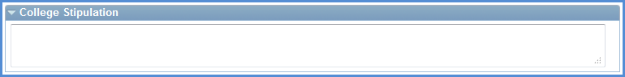

Acknowledgment of Academic Agreement:
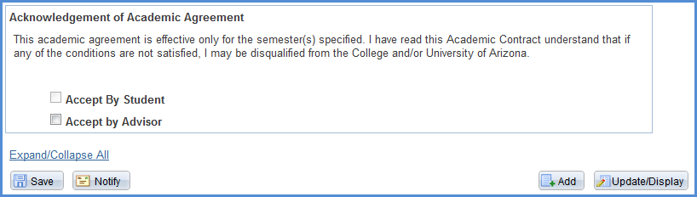
The Acknowledgment of Academic Agreement is where advisors and student can electronically “sign” the agreement. Once either the advisor or student clicks the “Accept” box the agreement is locked and cannot be edited (except for the Advisor Additional Stipulations comment box). If that box is not checked by either party, then the agreement may still be edited.

The advisor acceptance only displays to students if checked. Otherwise, students only see that they need to accept the agreement.

Remember to Save the agreement once all edits have been made.

Viewing Academic Agreements:

Viewing Academic Agreements in Student Services Center:
Academic agreements will be viewable by staff in two locations (depending on security). The first place is in Student Services Center: Main Menu > Campus Community > Student Services Center.

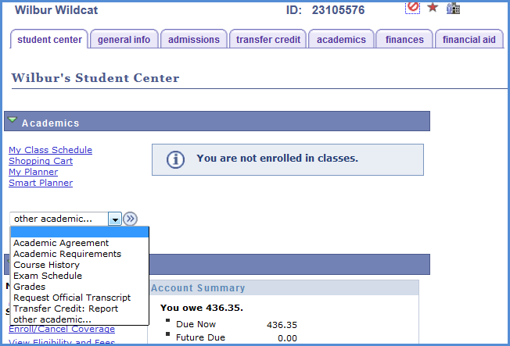
The Academic Agreement page can be accessed using the drop-down menu on the Student Services Center main page.

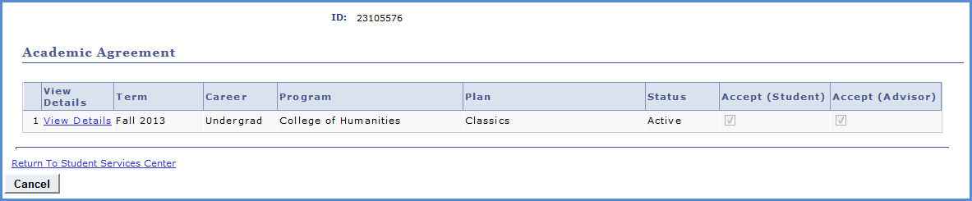
Click “View Details” to see the specific terms of the Academic Agreement

Like the Student View (see below) the view of the Academic Agreement in Student Services Center will only display stipulations and conditions that contain values.
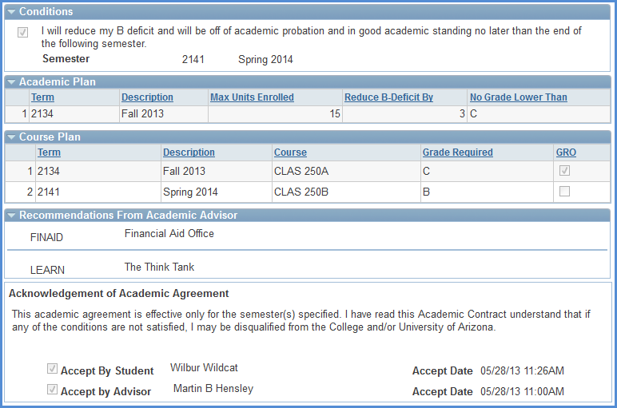

Note: Academic Agreements in Student Services Center are view only. If any edits need to be made or if you need to accept the Academic Agreement you must do so from the Academic Advising menus.

Viewing Academic Agreements from Academic Advising Menus:
The second place to view Academic Agreements is under the Academic Advising menus at the following navigation, if you have the appropriate security: Main Menu > Academic Advisement > Student Advisement > Academic Agreements.

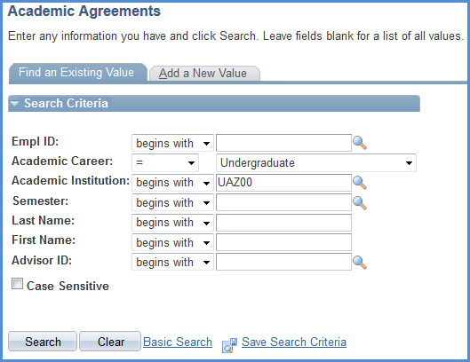
Use the “Find an Existing Value” tab to search for an Academic Agreement based on the available search criteria.

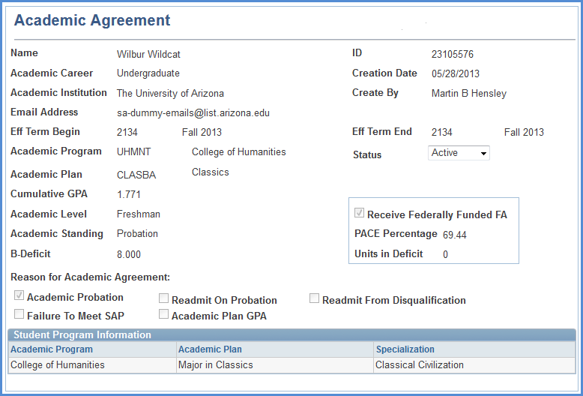
Because this Academic Agreement has been accepted it is locked and mostly static. However, the status of the Academic Agreement can be changed from Active to Inactive.

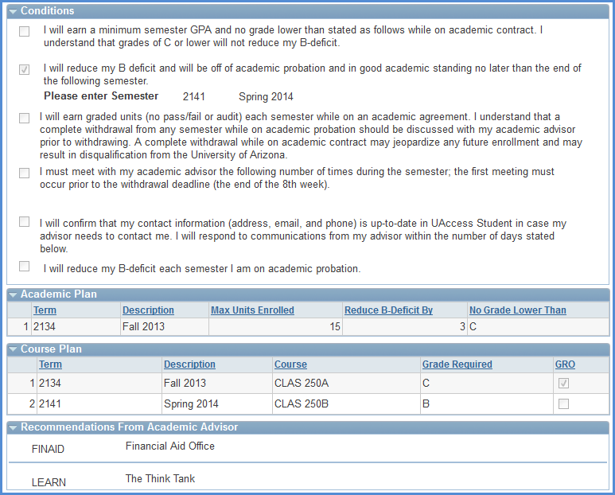
Also, even though no Advisor Additional Stipulations had been included this section is available for editing so advisors can make amendments or comments to the agreement. If a comment already exists, use the to add a new comment.
Unlike the view in Student Services Center, all of the Conditions are displayed regardless if they are checked or not.
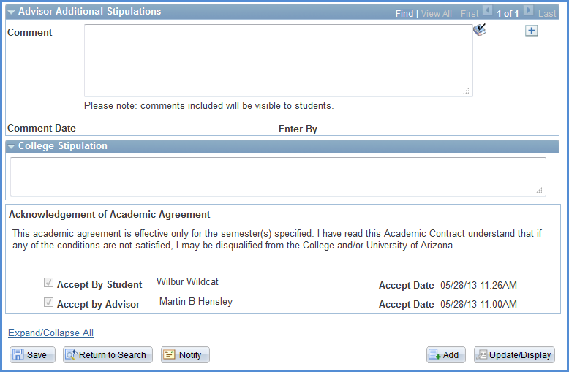
If you add any comments or change the active/inactive status of the Academic Agreement be sure to Save before leaving the page so your updates take effect.

Note: If an Academic Agreement is accessed from the advising menus and it has not been accepted and, in turn, locked by either an advisor or a student then the Academic Agreement is completely editable as if it was a new agreement.

Academic Agreements in Student Center:

Student Access of Academic Agreement:
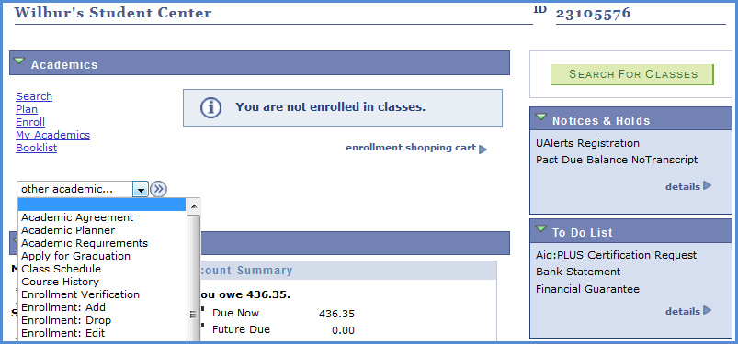
Students with an Academic Agreement can access it from two locations in Student Center. The first is by selecting Academic Agreement from the drop-down menu. The second is by going to their “My Academics” page.

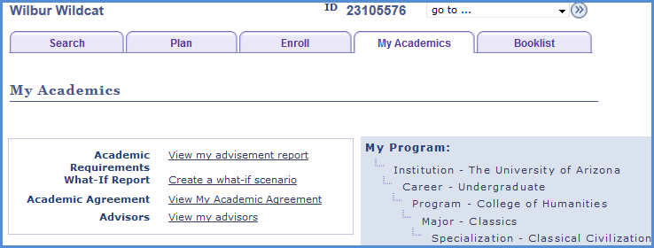
Additionally, Students accessing the Academic Agreement from the “My Academics” page will need to click “View My Academic Agreements” to navigate to the Academic Agreements page.

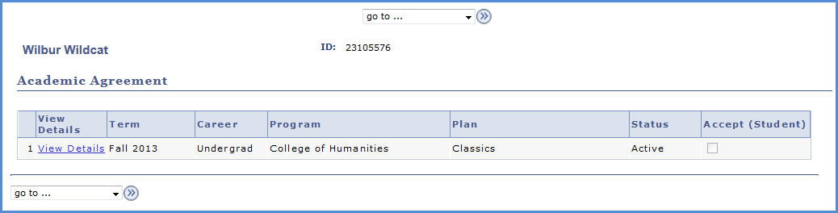
On the Academic Agreement page students will see any and all academic agreements. They can view the specifics of any agreement by clicking the “View Details” link.

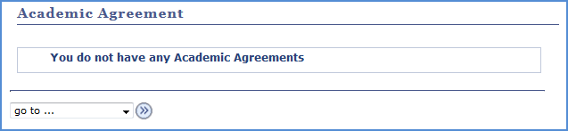
If the student does not have any Academic Agreements on file they will receive a message.

Student View of Academic Agreements:
When students access Academic Agreements they will only see the stipulations added by advisors, so as to make the agreement as concise and clear as possible.

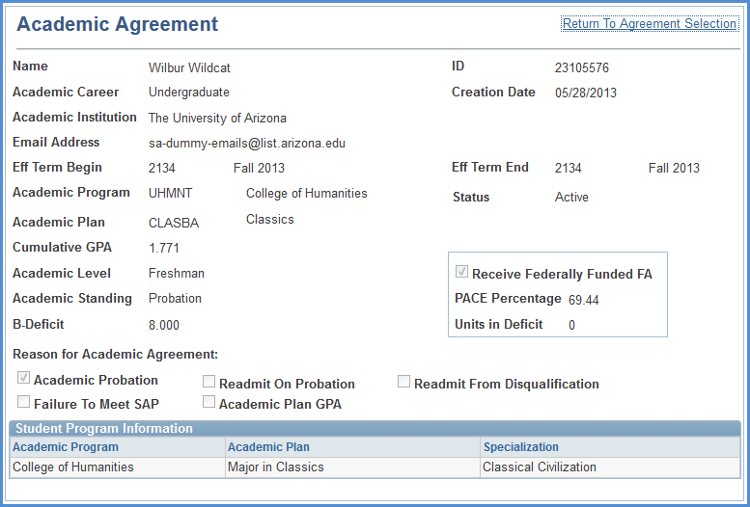
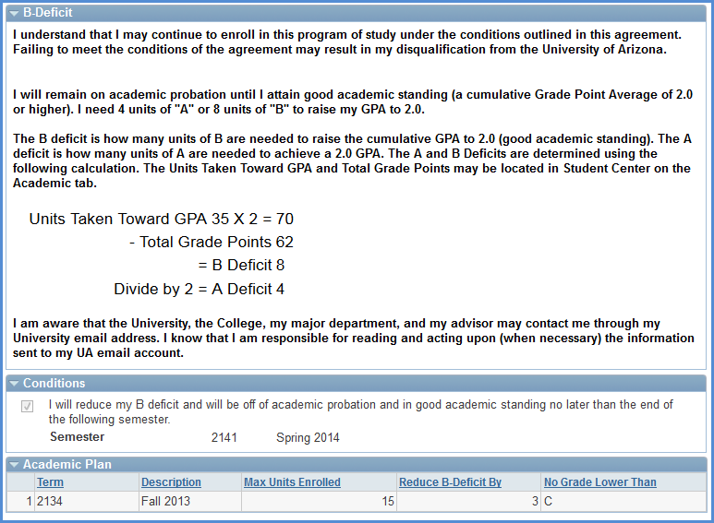
The only Conditions that display on the agreement are the ones that were checked by the advisor (or set as default values for auto-generated agreements)
In this example both the Advisor Additional Stipulations and College Stipulations were not included so they do not appear on the Academic Agreement, so it goes from Recommendations to the Acknowledgment section.
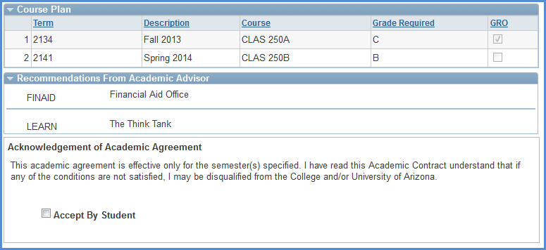
If the agreement has not been accepted by the advisor the student will not see that the advisor acceptance is pending.

However, if an advisor has accepted the Academic Agreement the advisor’s virtual signature will appear on the Academic Agreement with a name and date stamp.
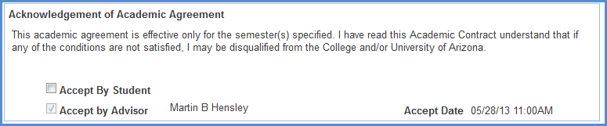

Once / if the student accepts the Academic Agreement his/her virtual signature will also appear.
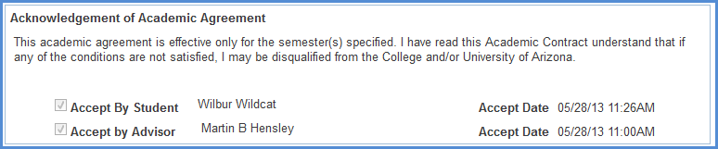

College Default Values:
Advising Directors/Coordinators in each college will have the ability to set default values for the Academic Agreements for the college at Main Menu > Academic Advisement > Student Advisement > Academic Agreement Defaults. Default values are based on the student’s program (college) and academic standing (probation or subject to dismissal). Different values can automatically populate the Academic Agreement if defaults are set. Previously establish defaults can be maintained and updated using the “Find An Existing Value” tab.

Creating Academic Agreement College Default Values:
Add a new value indicating the Academic Program and Academic Standing Status for which you want to create defaults.
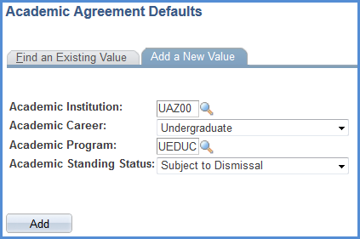

Academic Agreement College Default Set-Up:
The top of the pages displays the values for which you are creating defaults (College of Education-Subject to Dismissal students in this example).
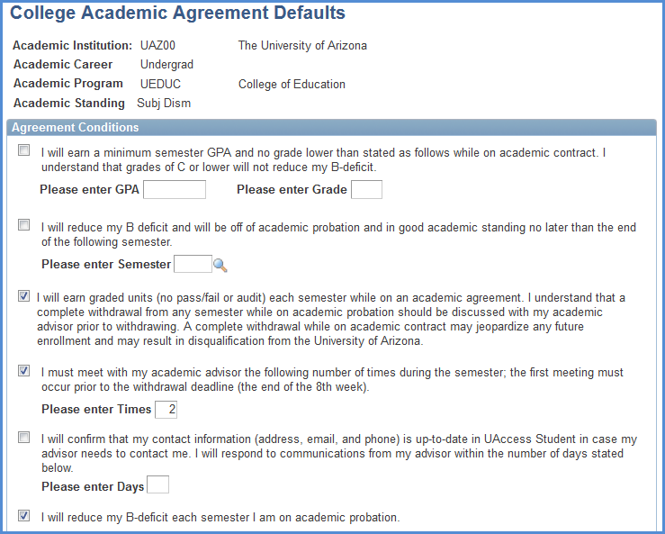
The set-up mimics the functionality of the Academic Agreement page. Any Conditions checked here will populate on the Academic Agreements for College of Education students who are subject to dismissal.
Default messaging can be included to give the students within this population specific messaging.
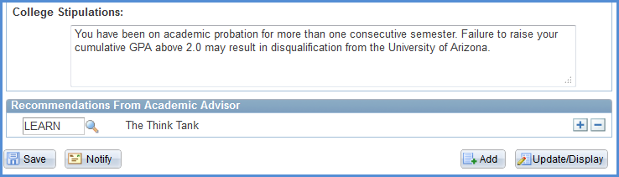
Default recommendations can also be set.

When an advisor creates an Academic Agreement for a program (college) that has default values those values will automatically populate the Academic Agreement. The advisor may delete or modify those default stipulations if they desire.

Academic Plan and Course Plan cannot be set to display default values. This is because those items are highly variable between students. The Advisor Additional Stipulations section also does not appear because that functionality is mimicked by the College Stipulation box; this also allows for differentiation between what the college may expect of the student and what the student’s advisor expects.

The importance of the college default values is that they allow colleges to put stipulations on the Academic Agreements for students in their college without having to manually input each stipulation on each student. These college default values (if any exist) will appear on auto-generated Academic Agreements. Based on the defaults, the following Academic Agreement was auto-generated for the student in Student Center:
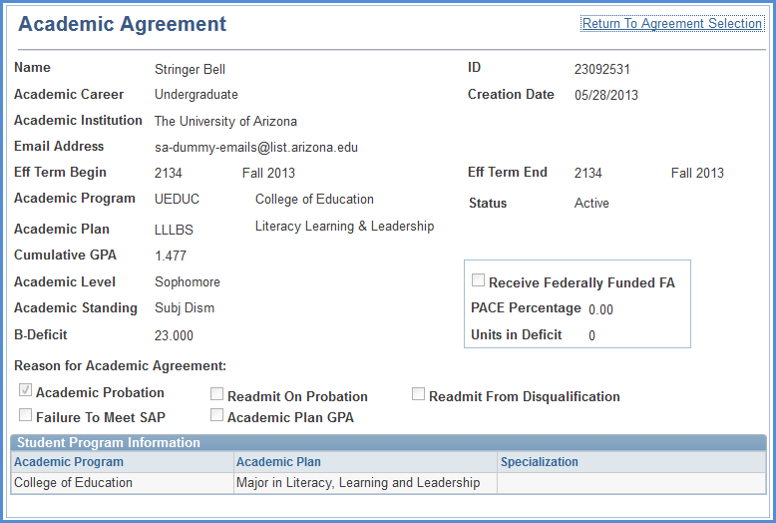
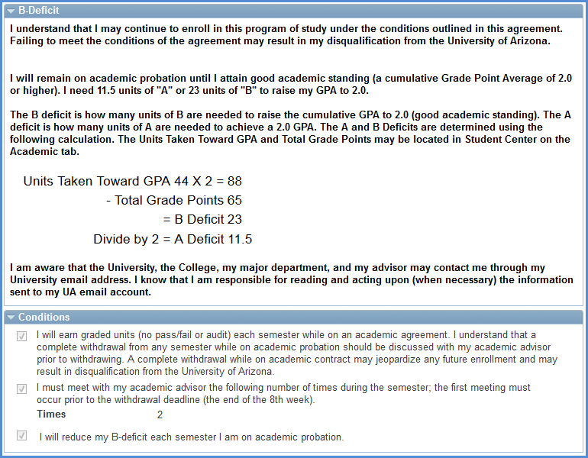
The conditions and associated values set on the default page populated the Academic Agreement automatically.
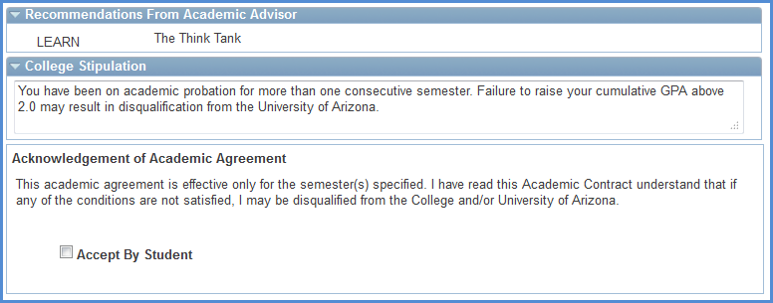

Availability of Academic Agreements:
Students will have access to Academic Agreements based on settings maintained by the Student Administration – Academic Advising team in UITS. At the end of the grace period SA-AA personnel, in collaboration with the Advising Resource Center, will adjust the term availability for Academic Agreements. The term settings indicate the terms for which students can view Academic Agreements as well as the auto-generation of Academic Agreements.

Here the term availability is set to 2131 (Spring 2013). When Wilma Wildcat accesses her Academic Agreements in Student Center she only sees her Spring 2013 Academic Agreement.
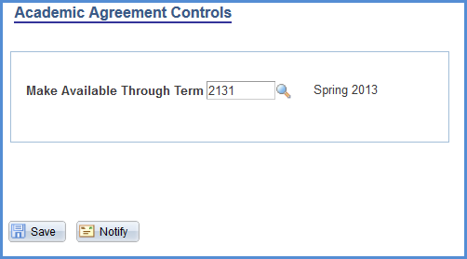

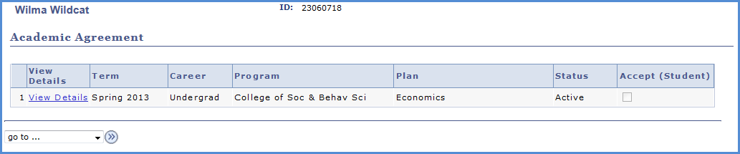

When the term is changed to 2134 (Fall 2013) and Wilma accesses her Student Center UAccess will look for an existing Academic Agreement for Fall 2013. When it does not find an Academic Agreement for Fall 2013 it auto-generates one for Wilma for Fall 2013, which then appears in her Student Center.
