Advisor Assignments Modification
Stage: Development
March 12, 2013
Screen shots for UAAC

Image one: page one of what advisors and students may see.
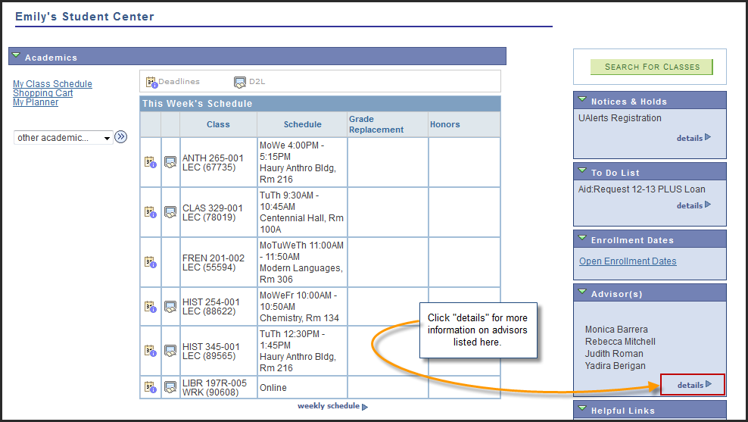

Image two: details page.
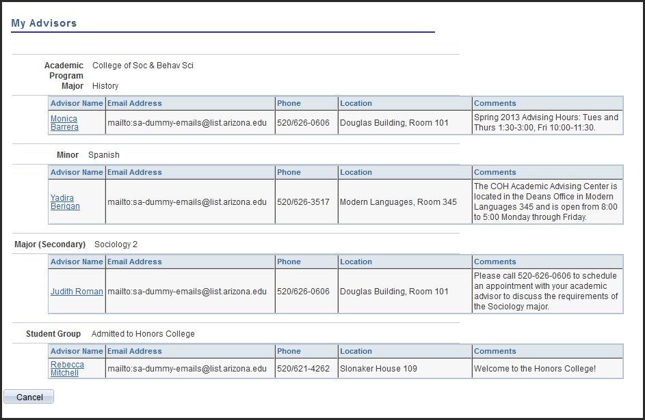

Image three: set-up page and the rules by which students may be assigned to their advisors.
Below we see that this advisor advises History majors with last names that begin with the letter A-L. Additional roles may be assigned to this particular advisor by clicking on the plus button within the "Instructor/Advisor Role" section, on the right-hand side.
(Please note that the comments are just an example of what may be included in this section.)
