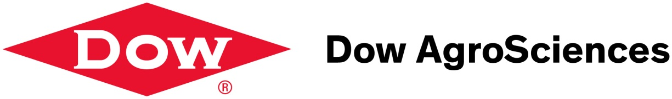
Dow Agroscience Information Session

Students from all CALS majors are encouraged attend this information session about career opportunities with Dow Agroscience in Sales and Marketing as well as many other prospective career paths.

Friday February 8, 2013 4PM
Marley 230

This is a chance to learn and ask question.Dow Agroscience is one of the world’s leading agriculture companies and they want YOU!
