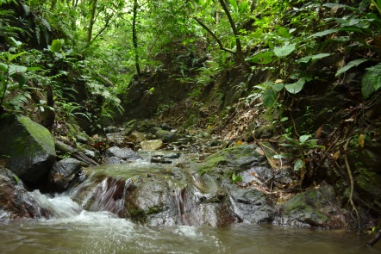



Come start the new year off right by joining the Spring 2012 Agriculture Internship! We will be setting down infrastructure, which will provide the foundation for future Kalu Yala community farmers. Interns will be building greenhouses, designing and implementing agroforestry systems, and installing crops using permaculture methods. Other tasks include growing & planting exotic fruits, tropical vegetables, and other useful agricultural products. Agro-pastoral systems, including the use of chickens, cattle, and other livestock, will be applied to or organic farm micro-ecosystem.
For more information on the internship contact Ashley Davis at internships@kaluyala.com or go to www.kaluyala.com/community Act today and support positive change in our generation!

Kalu Yala

Agriculture Internship
Spring 2012

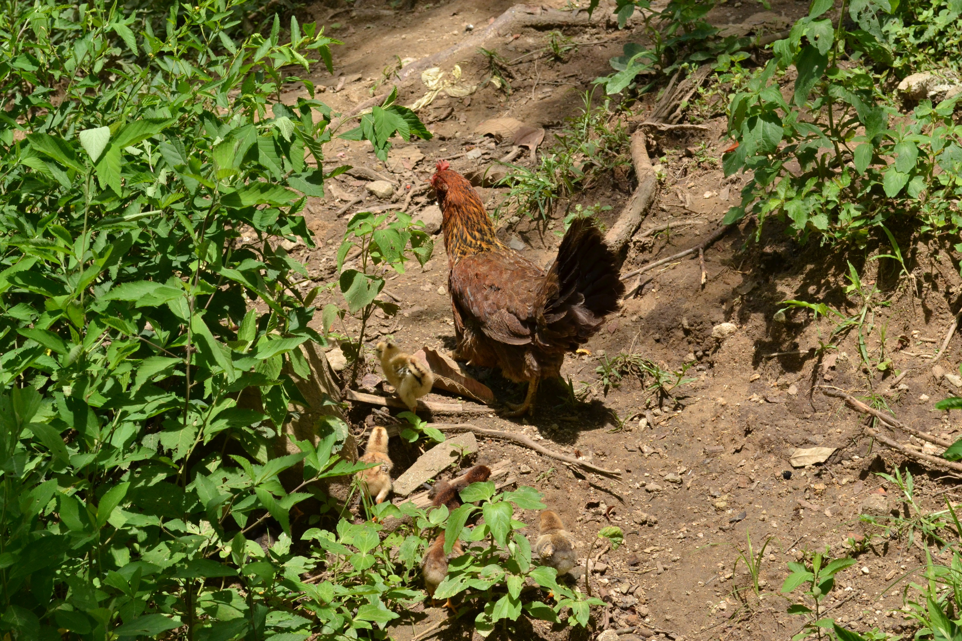informatioN]

