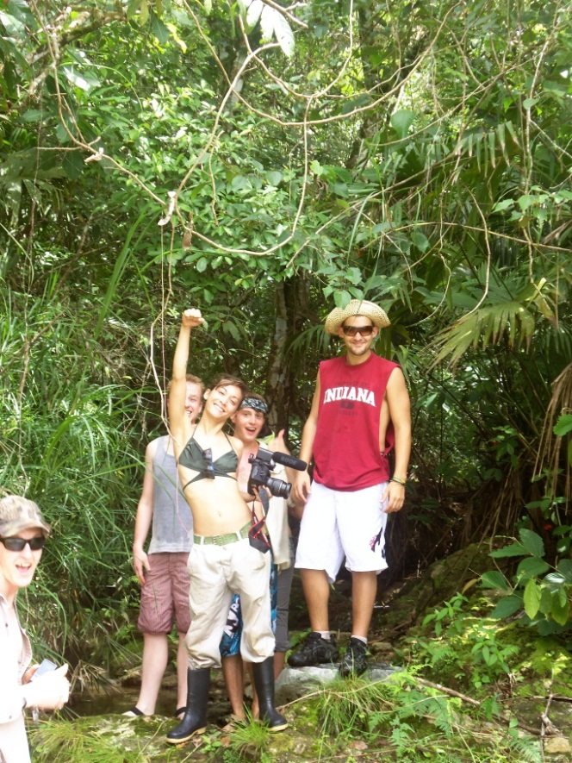
Kalu Yala Livestock Program: Spring 2012 Internship Experience!!
Kalu Yala is a start- up company that is working to build a sustainable community in the central highlands of Panama.

We are looking for interns who are passionate about living sustainably. Students from all majors can apply.

Help us bring sustainable practices to our property and make the Kalu Yala community a reality!

The Livestock Internship Program is one of Kalu Yala’s newest internship opportunities
Our goals for the spring include:
-Building a chicken run and hen house
-Building a loafing shed to house horses
-Purchasing chickens, cattle, horses and goats and making them an integral part of our Kalu Yala family!
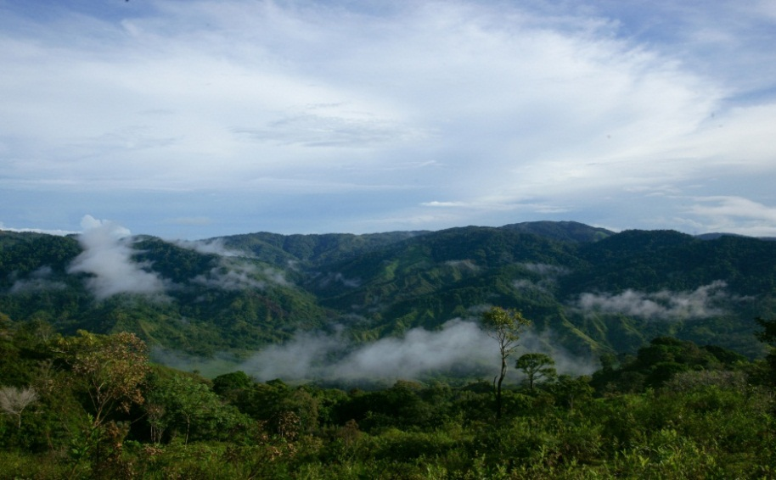
TO APPLY:
Please fill out a brief application (which can be found in the attached spring 2012 internship packet)
Submit your application to internships@kaluyala.com
For direct questions about the program, feel free to email me at kylie.bechdolt@gmail.com
Come be a part of this incredible experience!!

