Adventures await down the Iguana River…

Gain college credit while working and traveling in Panama!

Future site of the Kalu Yala Organic Farm!!

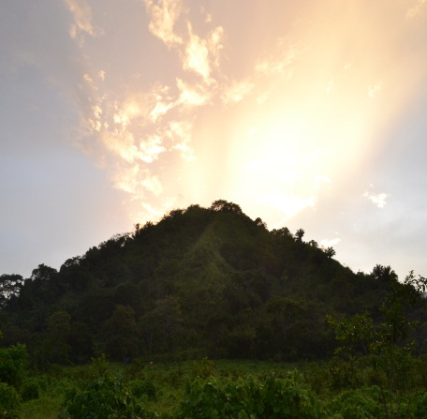
Kalu Yala is in a 7,000 acre valley that backs up to a 320,000 acre national park and sits at the headwaters of a 90,000 acre watershed. Primary rainforest covers 50 percent of the breathtaking valley, while the rest is currently used for cattle grazing and organic farming. Kalu Yala is located 50 minutes from Panama City's central business district and 35 minutes from the international airport. The village we are designing in the valley will eventually have a population of over 10,000 people, while inhabiting less than 20% of the land. Kalu Yala is starting an organic farm and is looking for your help. Kalu Yala is actively pursuing applicants for their Spring 2012 Internship!! Make a real difference in this world and apply today!

